**AWS**

**Git Hub** [URl: -](URl:%20-)

<https://github.com/iam-veeramalla/aws-devops-zero-to-hero#readme>

**YouTube Channel**

<https://www.youtube.com/watch?v=GkKNxyLp_V0&list=PLdpzxOOAlwvLNOxX0RfndiYSt1Le9azze&index=1>

**References Note’s:**

https://www.guru99.com/aws-tutorial.html

https://www.edureka.co/blog/amazon-aws-tutorial/#intro

**Day-1**

* **what is cloud?**
* **public vs Private cloud**
* **why is public cloud so popular?**
* **Why aws, why not other cloud’s**
* **Trends of people moving back to private cloud?**
* **Create an AWS account and get started.**

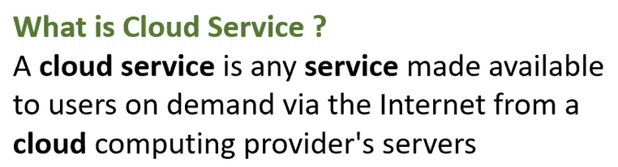

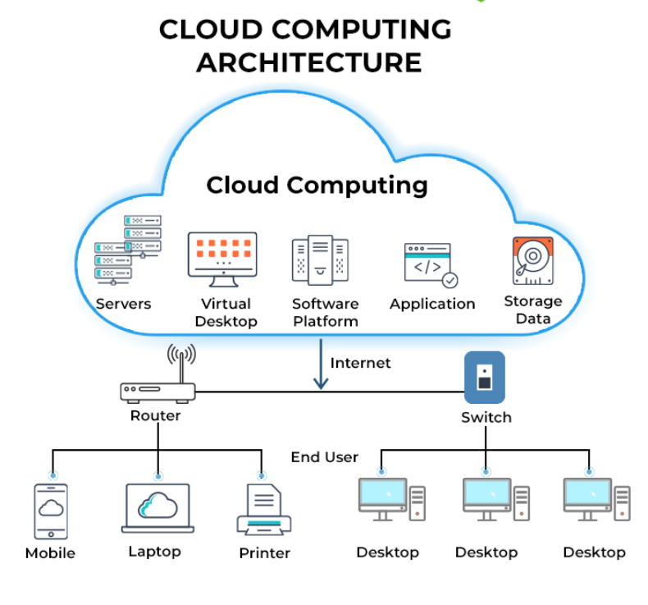

**What is Cloud Computing?**

🡺Cloud computing is a term **referred to storing and accessing data** over the **internet**.

🡺 It doesn’t store any data on the hard disk of your personal computer. In cloud computing, you can **access data from a remote server**.

🡺Cloud computing is a **pay-as-you-go model** for delivering IT resources.

🡺It is the delivery of computing services-servers, storage, databases, networking, software, analytics and more-over the internet.

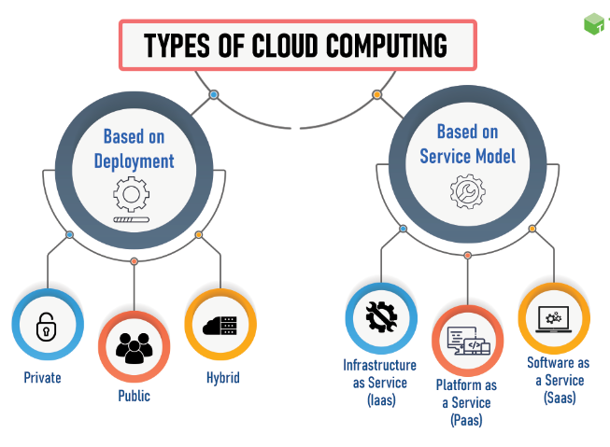

## Private Cloud

🡺Private cloud is also known as an **internal cloud** or **corporate cloud**. It is used by organizations to build and manage their own data centres internally or by the third party.

🡺 A [private cloud](https://www.cloudflare.com/learning/cloud/what-is-a-private-cloud/) is a cloud service that is not shared with any other organization. The private cloud user has the cloud to **themselves**.

**public cloud**

🡺Public cloud is open to all to store and access information via the Internet using the **pay-per-usage method**.

🡺 A public cloud is a **cloud service** offered to multiple customers by a cloud provider.

**Hybrid Cloud:**

🡺**Hybrid cloud** is a [cloud computing](https://www.alibabacloud.com/knowledge/what-is-cloud-computing) model that combines one or more public cloud and private cloud environments through a network connection, which allows for **sharing of data and applications** between the different cloud environments.

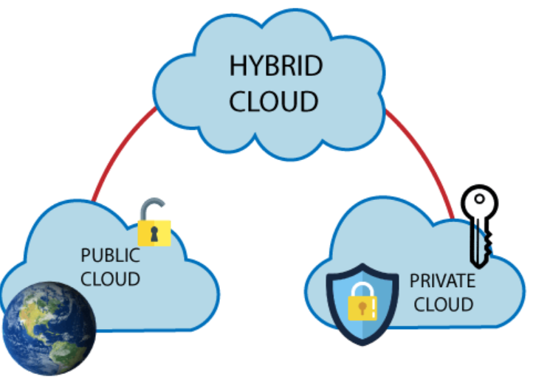

**SaaS (Software as a Service):** It allows companies to use software without having to purchase them, which reduces the expenditure of the company drastically, since they are already installed on the cloud server they can be quickly deployed and therefore saves time.

**PaaS (Platform as a Service)** It allows developers to build applications, collaborate on projects without having to purchase or maintain infrastructure.

**IaaS (Infrastructure as a Service)** It allows companies to rent servers, storage space, etc. from a cloud provider.

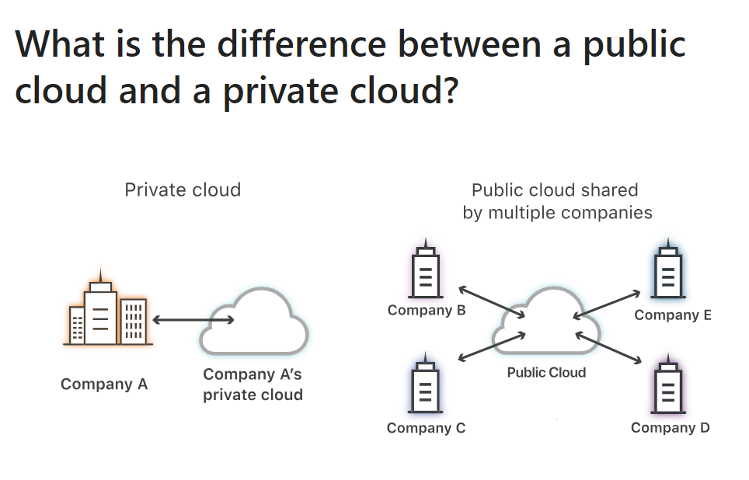

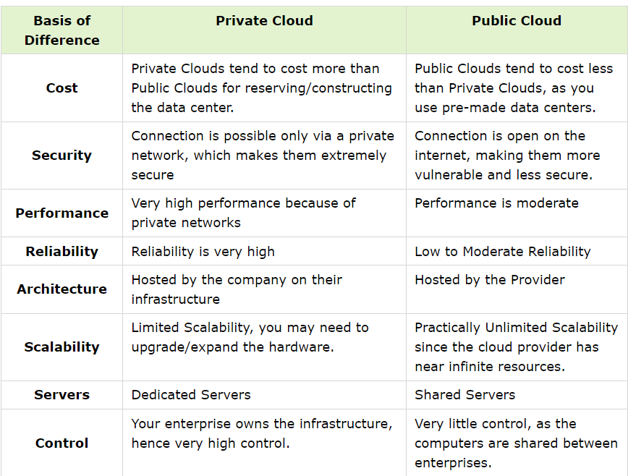

**why is public cloud so popular?**

🡺A public cloud **provides easy and fast scalability of compute, storage, and other web-based resources.** Servers can be deployed in minutes or hours, instead of days or weeks.

🡺Low Cost, Save Time and Quickly and easily set up.

**Why is AWS better than other cloud services?**

🡺AWS has significantly **more services, and more features within those services,** than any other cloud provider–from infrastructure technologies like compute, storage, and databases–to emerging technologies, such as machine learning and artificial intelligence, data lakes and analytics, and Internet of Things. This makes it faster, easier, and more cost effective to move your existing applications to the cloud and build nearly anything you can imagine**.**

1. **Free-tier Service Availability**
2. **On-demand Pricing Model**
3. **Most Secure**
4. **Fast-paced Innovation**
5. **Widest Partner Network**

**Day-2**

**IAM (Identity and Access Management)**

🡺Explore IAM, which is used for managing access to AWS resources.

🡺How to create IAM users, groups, and roles, and how to apply permissions and security best practices to ensure proper access control.

🡺What is Authentication and authorization

**Note**: **Root user –** Account Owner that performs tasks requiring.

**IAM** --> User within an account that **performs daily tasks**.

**🡺 AWS IAM (Identity and Access Management)**

**User, policies and groups and roles**

**AWS Security**

🡺AWS Security refers to a range of qualities, tools, or features that make the public cloud service provider Amazon Web Services (AWS) secure.

There are many types of security services available but some of them are widely used by AWS, such as:

* **IAM**
* **Key Management System (KMS)**
* **Cognito**
* **Web Access Firewall (WAF)**

**What is AWS IAM, and why is it important?**

🡺AWS IAM (Identity and Access Management) is a service provided by Amazon Web Services that helps **you control access to your AWS resources**. It allows you to manage user identities, permissions, and policies.

🡺You can IAM to control who is **authenticated (Signed-In)** and **Authorized (has Permissions)** to use resources.

**why is it important?**

🡺IAM is important because it enhances security by ensuring that only authorized individuals or entities have access to your AWS resources, helping you enforce the principle of least privilege and maintain a secure environment.

**Authenticated and Authorization**

* **Authentication** confirms that users are **who they say they are.**
* **Authorization** gives those users **permission to access** a resource.
* While authentication and authorization might sound similar, they are distinct security processes in the world of identity and access management (IAM).

What Is Authentication?

* Authentication is the act of validating that **users are whom they claim to be.** This is the first step in any security process.

**Complete an authentication process with:**

* **Passwords.**Usernames and passwordsare the most common[**authentication factors**](https://www.okta.com/products/adaptive-multi-factor-authentication/). If a user enters the correct data, the system assumes the identity is valid and grants access.
* [**One-time pins**](https://www.okta.com/blog/2020/06/what-is-a-one-time-password-otp/)**.** Grant access for only one session or transaction.
* **Authentication apps.**Generate security codes via an outside party that grants access.
* [**Biometrics**](https://www.okta.com/blog/2020/07/biometric-authentication/)**.**A user presents a fingerprint or eye scan to gain access to the system.

**What Is Authorization?**

🡺Authorization in system security is the process **of giving the user permission to access a specific resource or function.** This term is often used interchangeably with access control or client privilege.

🡺Giving someone permission to download a particular file on a server or providing individual users with administrative access to an application are good examples of authorization.

🡺In secure environments, authorization must always follow authentication. Users should first prove that their identities are genuine before an organization’s administrators grant them access to the requested resources.

**Users:** -

1. An IAM user is an **identity** within AWS that represents an individual or application needing **access to AWS resources**.
2. IAM users have **permanent long-term credentials,** such as a username and password, or access keys (Access Key ID and Secret Access Key).
3. IAM users can be assigned directly to IAM policies or added to IAM groups for easier management of permissions.

**Policies**:

🡺 IAM policies are **JSON documents** that define **permissions**. Policies specify the actions that can be performed on AWS resources and the resources to which the actions apply.

🡺 Policies can **be attached to users, groups, or roles to control access.** IAM provides both AWS managed policies (predefined policies maintained by AWS) and customer managed policies (policies created and managed by you).

**Groups:**:

🡺 IAM groups are collections of users with similar access requirements. Instead of **managing permissions** for each user individually, you can assign permissions to groups, making it easier to manage access control. **Users can be added or removed from groups as needed.**

**Roles:**

🡺IAM roles are **used to grant temporary access** to AWS resources.

🡺Roles are typically used by applications or services that need to access AWS resources on behalf of users or other services. Roles have **associated policies that define the permissions and actions allowed for the role.**

**Note:** For Interview point

🡺Are you using the root user.

* No, we don’t used Root User as devops engineer team are r created a AWS account we have to created **IM User** for Devops engineers and we granted access what we want

**What is the principle of least privilege, and why is it important in IAM?**

* The principle of least privilege states that users should be granted only the permissions necessary to perform their tasks and nothing more. It is important in IAM because it minimizes the risk of unauthorized access and limits the potential damage that could be caused by a compromised account. Following the principle of least privilege helps maintain a secure environment by ensuring that users have only the permissions they need to perform their job responsibilities.

**What is an AWS managed policy?**

🡺An AWS managed policy is **a predefined policy created** and managed by AWS. These policies cover common use cases and provide **predefined permissions for specific AWS services** or actions. AWS managed policies are maintained and updated by AWS, ensuring they stay up to date with new AWS services and features. They can be attached to IAM users, groups, or roles in your AWS account.

**What is an Inline Policy?**

🡺 **An inline policy is a policy created for a single IAM identity (a user, group, or role). Inline policies maintain a strict one-to-one relationship between a policy and an identity.** They are deleted when you delete the identity. You can create a policy and embed it in an identity, either when you create the identity or later. If a policy could apply to more than one entity, it’s better to use a managed policy.

**permissions boundary in IAM**

🡺A permissions boundary **is an advanced feature for using a managed policy to set the maximum permissions that an identity-based policy can grant to an IAM entity**. An entity's permissions boundary allows it to perform only the actions that are allowed by both its identity-based policies and its permissions boundaries.

**DAY- 3: EC2 Instances**

🡺how to launch EC2 instances, connect to them using SSH, and understand key concepts such as instance types, security groups, and key pairs.

**EC2:**

- Amazon **Elastic Compute Cloud** (Amazon EC2) is a web service that provides secure, resizable compute capacity in the cloud.

- Access reliable, scalable infrastructure on demand. Scale capacity within minutes with SLA commitment of 99.99% availability.

- Provide secure compute for your applications. Security is built into the foundation of Amazon EC2 with the AWS Nitro System.

- Optimize performance and cost with flexible options like AWS Graviton-based instances, Amazon EC2 Spot instances, and AWS Savings Plans.

EC2 use-cases:

* Deliver **secure, reliable, high-performance, and cost-effective** compute infrastructure to meet demanding business needs.
* Access the on-demand infrastructure and capacity you need to run HPC applications faster and cost-effectively.
* Access environments in minutes, **dynamically scale capacity as needed, and benefit from AWS’s pay-as-you-go pricing.**
* Deliver the broadest choice of computer, networking (up to 400 Gbps), and storage services purpose-built to optimize price performance for ML projects.

**EC2 Instance Types:**

1. **General Purpose Instances:** (**t3, t4g, t3a, t4g, t3e**) It designed to deliver a **balance of compute, memory, and network resources**. They are suitable for a wide range of applications, including web servers, small databases, development, and test environments, and more.

2**. Compute Optimized Instances:** It provide a higher ratio of compute power to memory. They excel in **workloads that require high-performance processing such as batch processing**, scientific modelling, gaming servers, and high-performance web servers.

3. **Memory optimized:** It they are suitable for applications that **require large amounts of memory, such as in-memory databases, real-time big data analytics**, and high-performance computing.

4. **Storage optimized:** It designed for workloads that require high, sequential read and write access to very large data sets on local storage.

5. **Accelerated computing:** It use hardware accelerators, or co-processors, to perform functions such as floating-point number calculations, graphics processing, or data pattern matching more efficiently than software running on a general-purpose CPU.

=======

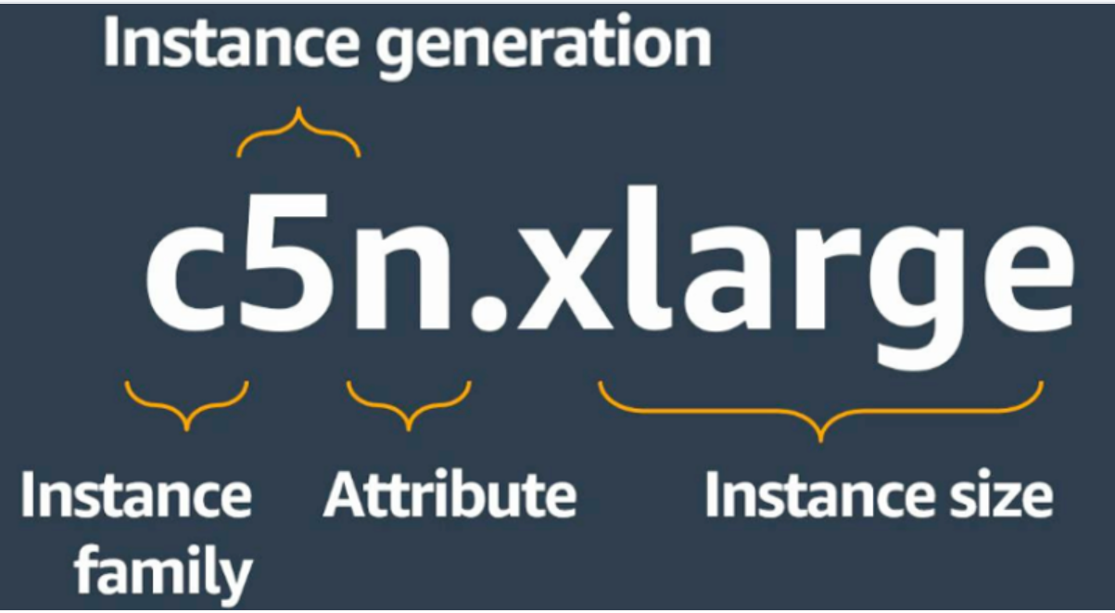

**Instance families**

* C – Compute
* D – Dense storage
* F – FPGA
* G – GPU
* Hpc – High performance computing
* I – I/O
* Inf – AWS Inferentia
* M – Most scenarios
* P – GPU
* R – Random access memory
* T – Turbo
* Trn – AWS Tranium
* U – Ultra-high memory
* VT – Video transcoding
* X – Extra-large memory

**Additional capabilities**

* a – AMD processors
* g – AWS Graviton processors
* i – Intel processors
* d – Instance store volumes
* n – Network and EBS optimized
* e – Extra storage or memory 🡺 z – High performance

Explain Auto Scaling in EC2 and how it helps ensure application availability.

🡺Auto Scaling is a service that allows you to automatically adjust the number of EC2 instances in response to changing application demands.

🡺It helps maintain application availability, improves fault tolerance, and optimizes resource usage by scaling out during periods of high demand and scaling in during lower demand.

### [**Explain the differences between on-demand, reserved, and spot instances.**](https://github.com/iam-veeramalla/aws-devops-zero-to-hero/blob/main/interview-questions/elastic-cloud-compute.md#4-explain-the-differences-between-on-demand-reserved-and-spot-instances) **(OR) what are the EC2 Purchasing Options?**

1. **On-Demand Instances:** Pay-as-you-go pricing with no upfront commitment.
2. **Reserved Instances**: Provides capacity reservation at a lower cost in exchange for a commitment.
3. **Spot Instances:** Allows users to bid on unused EC2 capacity, potentially leading to significantly lower costs.

### [**Explain the difference between public IP and Elastic IP in EC2.**](https://github.com/iam-veeramalla/aws-devops-zero-to-hero/blob/main/interview-questions/elastic-cloud-compute.md#8-explain-the-difference-between-public-ip-and-elastic-ip-in-ec2)

1. A **public IP** is assigned to an instance at launch, but it can change if the **instance is stopped and started**.

2. An **Elastic IP** is a static IP address that can be associated with an instance, providing a consistent public IP even after stopping and starting the instance.

**AMAZON EC2 AUTO-SCALING**

Amazon EC2 Auto Scaling enables you to automatically add or remove Amazon EC2 instances across different AZs in response to changing application demand.

• **Dynamic scaling** responds to changing demand.

• **Predictive scaling** automatically schedules the right number of Amazon EC2 instances based on predicted demand.

🡺To scale faster, you can use dynamic scaling and predictive scaling together.

By adding Amazon EC2 Auto Scaling to an application, you can add new instances to the application when necessary and terminate them when no longer needed.

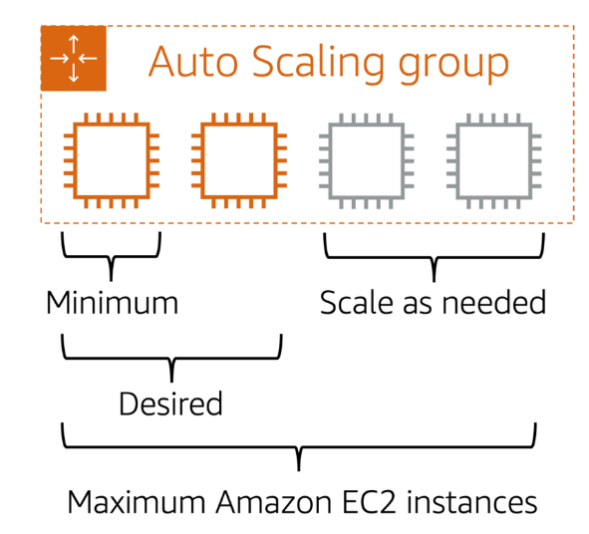

🡺If you do not specify the desired number of Amazon EC2 instances in an Auto Scaling group, the desired capacity defaults to your minimum capacity.

🡺 Max = up to 4 EC2 instances

**What is Dedicated host in Aws?**

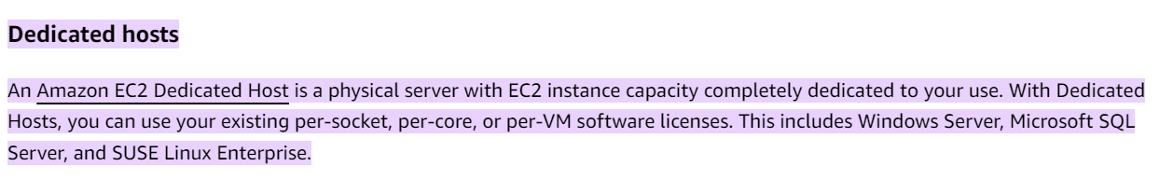

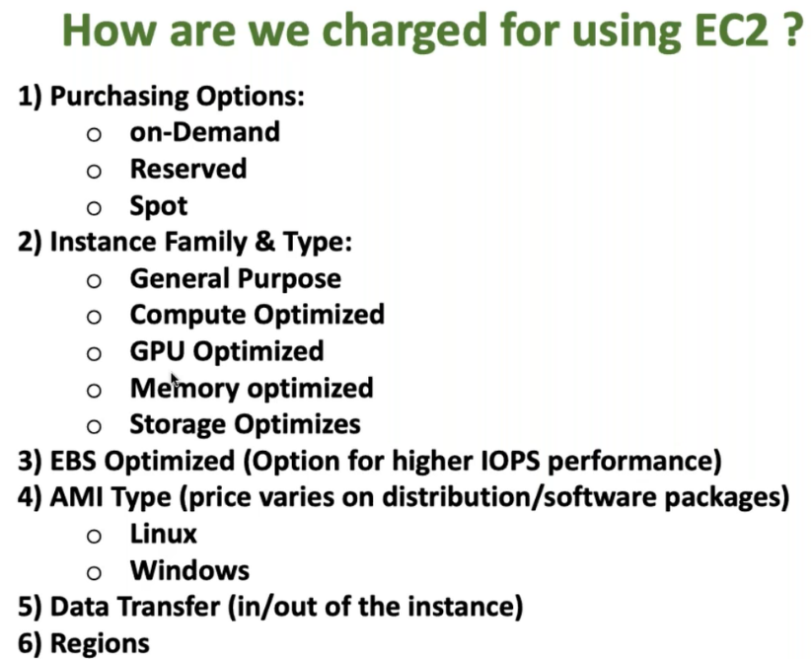

**what are key-pair in aws?**

**🡺**A key pair is a combination of a public key that is used to **encrypt data** and a private key that is used to **decrypt data.**

🡺A key pair is a set of cryptographic keys that consists of a public key and a private key. Key pairs are primarily used for secure authentication and access to Amazon Elastic Compute Cloud (Amazon EC2) instances.

🡺 When you create an EC2 instance, you can associate a key pair with it. The public key is placed on the instance, and the private key is kept securely by the user. When you want to connect to the instance, you use the private key to authenticate, ensuring secure access to your virtual server.

🡺Key pairs are crucial for securing access to EC2 instances and are an essential component of AWS's security infrastructure**.**

**Explain the concept of EC2 instance metadata and user data.**

**EC2 Instance Metadata:** EC2 instances have metadata that provides information about the instance, such as instance ID, public IP address, and IAM role. This metadata can be **accessed from within the instance.**

**User Data:** User data is a script or data that can be **passed to an EC2 instance during launch**. It is often used to perform instance-specific configuration and customization.

**DAY- 4: VPC**

AWS Networking (V PC)

* AWS networking concepts, with a specific focus on VPC (Virtual Private Cloud). You'll learn how to create and configure VPCs, subnets, and route tables, enabling you to design and manage the network infrastructure for your applications.

1. Internet gateway

2. Public Subnet

3.Load Balancer

4.Route Tables (Routers)

5.Security Groups

6.NAT-Gateways

7.NACL – Automation for your security groups where instead of defining the same thing again and again you can define that as part of NACL

8.VPC Flow Logs

**What is VPC?**

🡺A virtual private cloud is a **virtual network that closely resembles a traditional networking that you operate in your own data centre,** with the benefits of using the scalable infrastructure of AWS.

🡺VPC is a virtual network of data center inside AWS for **one client**.

🡺It is logically isolated from other virtual network in the AWS cloud.

🡺 **Maximum 5 VPC can be created in one region and 200 subnets in 1 VPC.**

🡺We can allocate maximum 5 Elastic IP.

🡺 Once we created VPC, DHCP, NACL and security group will automatically created.

🡺A VPC is confined to an AWS region and does not extend between regions.

🡺Once the VPC is created you cannot change its CIDR block range.

🡺 If you need a different CIDR size create a new VPC.

🡺 The different subnets within a VPC cannot overlap.

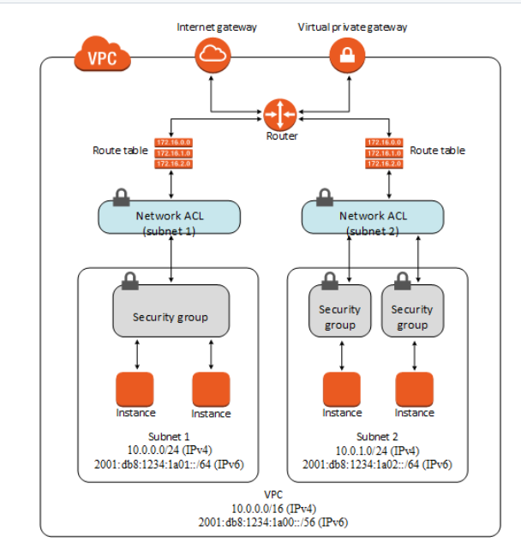

**Types of VPC**

**1. Default VPC:**

* Created in each AWS region when an AWS account is created.
* Has default CIDR, security group, NACL and route table settings. It an internet gateway by default.

2**. Custom VPC:**

* It is a VPC and AWS account owner creates.
* AWS user creating the Custom VPC can decide the CIDR.
* It has its own default security group, NACL and route tables.
* I t doesn’t have an internet gateway by default, one needs to be created if needed.

**Components of VPC:**

* CIDR and IP address subnets
* Implied Router and Routing table
* Internet Gateway
* Security Group
* NACL
* Virtual Private Gateway
* Peering Connectors
* Elastic IP

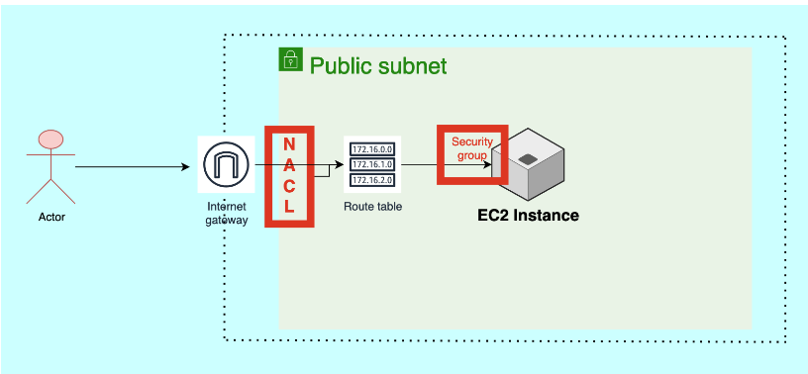

**CIDR – Classless Inter Domain Routing.**

**What is CIDR? -🡪 All IP address is private only.**

🡺**Classless Inter-Domain Routing (CIDR) is an IP address allocation method that improves data routing efficiency on the internet. Every machine, server, and end-user device that connects to the internet has a unique number, called an IP address, associated with it**. Devices find and communicate with one another by using these IP addresses. Organizations use CIDR to allocate IP addresses flexibly and efficiently in their networks.

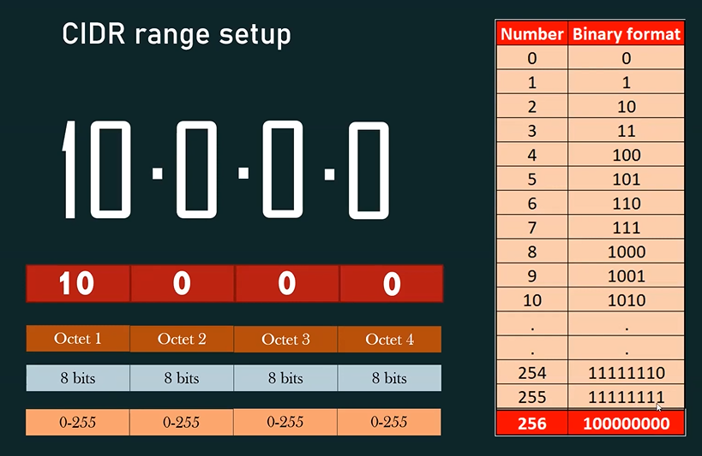

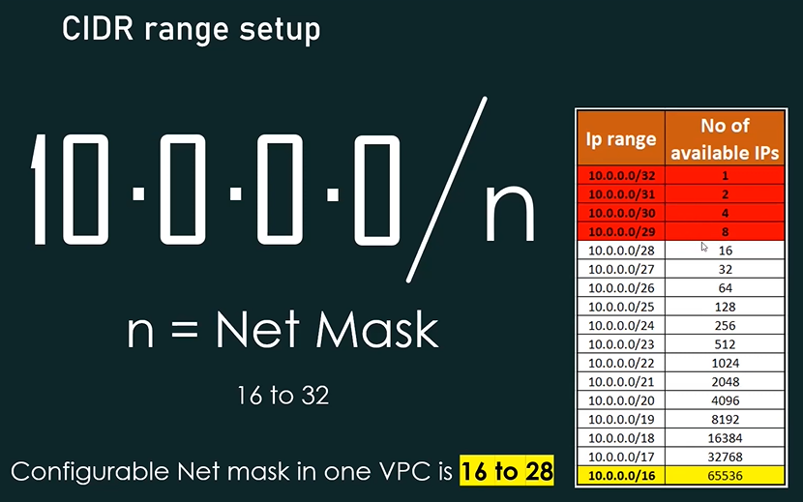

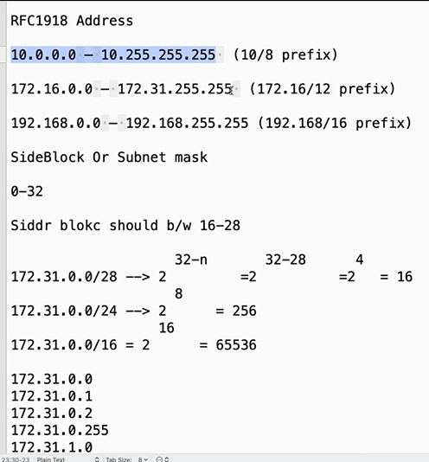

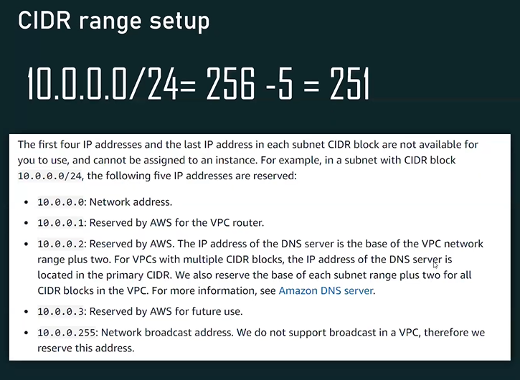

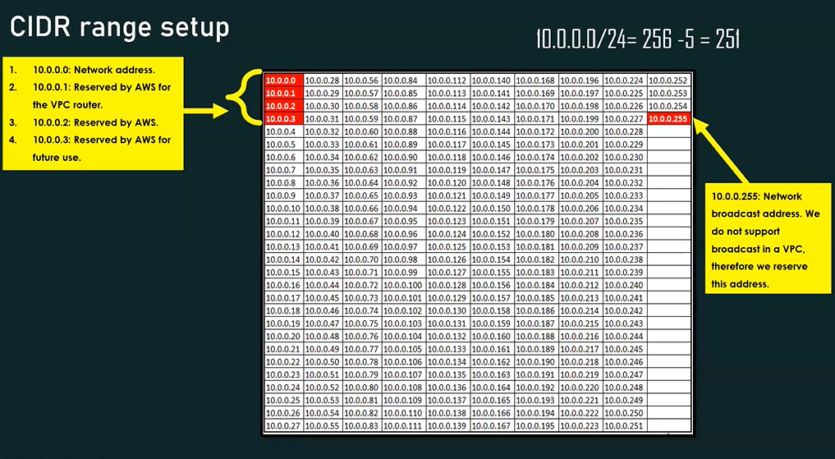

**IP- Address**

🡺You can assign IP addresses, both IPv4 and IPv6, to your VPCs and subnets. You can also bring your public IPv4 and IPv6 GUA addresses to AWS and allocate them to resources in your VPC, such as EC2 instances, NAT gateways, and Network Load Balancers.

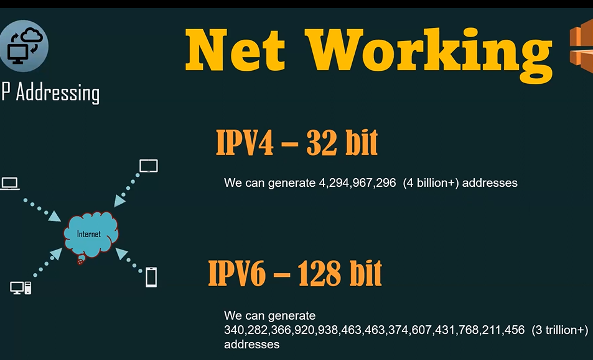

**What is IP?**

🡺 IP stands for **Internet Protocol,** a set of rules governing how devices on a network communicate with one another.

**What is IPv4?**

🡺 IPv4, or **Internet Protocol version 4**, is a version of the Internet Protocol (IP) that uses a number identifier to identify devices on a network. IPv4 addresses are **32-bit IP addresses** written in **decimal notation**.

**What is IPv6?**

🡺 IP version 6 is the new version of Internet Protocol, which is way better than IP version 4 in terms of complexity and efficiency. IPv6 is written as a group of **8 hexadecimal numbers** separated by colon (:). It can be written as **128 bits of 0s and 1s**.

**Sub-Net:**

A subnet is a **range of IP addresses in your VPC.** A subnet must reside in a single Availability Zone. After you add subnets, you can deploy AWS resources in your VPC.

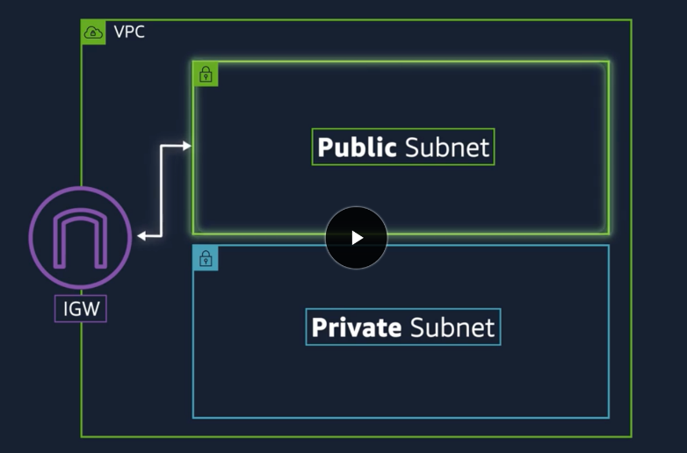

**Public Subnet:** If a subnet’s **traffic is routed to an internet gateway, the subnet is known as public subnet.** If you want your instance in a public subnet to communicate with the internet over IPV4, it must have a public IPV4 address or an Elastic IP address.

**Private Subnet:** if a subnet **doesn’t have a route to the internet gateway, the subnet is known as private subnet**. When you create a VPC you must specify an IPV4 CIDR block for the VPC. The allowed blocks size is between /16 to /28 networks. The first four and last IP address of subnet cannot be assigned.

🡺The instances in the public subnet can send outbound traffic directly to the internet, but instances in private subnet can’t.

For e.g: 10.0.0.0- network address

10.0.0.1- reserved by AWS for the VPC router.

10.0.0.2- reserved by AWS the IP address of DNS server.

10.0.0.3- reserved for future use.

10.0.0.255- broadcast address

**Note:** **AWS do not support broadcast in a VPC but reserve this address.**

**Routing and Routing Table:**

**🡺Use route tables to determine where network traffic from your subnet or gateway is directed.**

**🡺**A Route table contains a **set of rules**, called routes, that are used to determine where the data packets of the network traffic are directed.

* It is the central routing function.
* It connects the different AZ together and connects the VPC to the internet gateway.
* You can have up to 200 route tables per VPC.
* You can have up to 50 routes entries per route table.
* Each subnet must be associated with only one route table at any given time only.
* If you don’t specify a subnet to route table association, the subnet will be associated with the default VPC route table.
* You can also edit the main route table if you need but you cannot delete the main route table.

**Internet Gateway: ----> It will give public access and internet.**

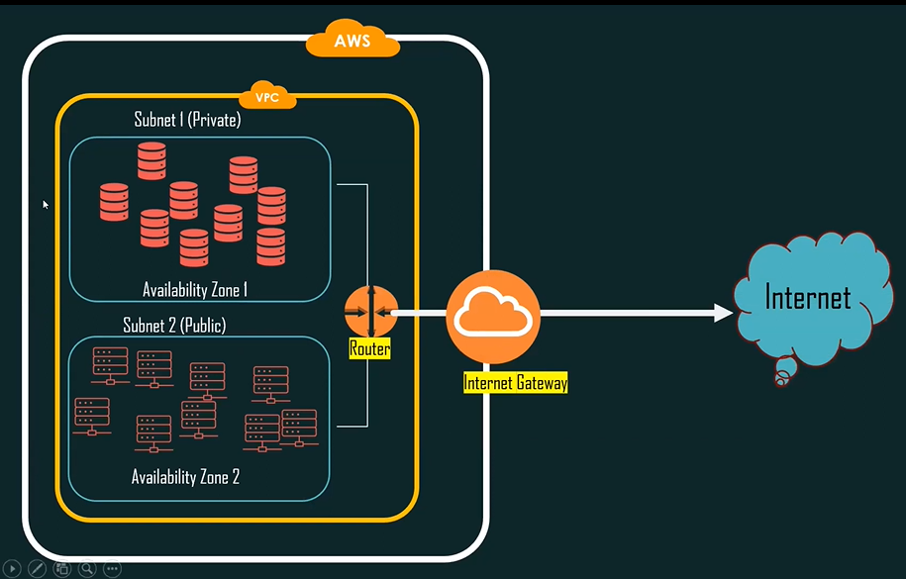

* **An internet Gateway (IGW) is a logical connection between an Amazon VPC and the internet. It is not a physical device. Only one can be associated with each VPC. It does not limit the bandwidth of internet connectivity.**
* **Ensure that your subnet’s route table points to the internet gateway.**
* **It performs NAT between your private and public IPV4 address.**
* **It supports both IPV4 and IPV6.**

**NAT Gateway:🡺NAT Gateway is a highly available AWS managed service that makes it easy to connect to the Internet from instances within a private subnet in an Amazon Virtual Private Cloud (Amazon VPC). Previously, you needed to launch a NAT instance to enable NAT for instances in a private subnet.**

**(OR)**

**🡺NAT Gateway service can use a NAT gateway so that instances in a private subnet can connect to services outside your VPC, but external services cannot initiate a connection with those instances.**

* **No need to assign public IP address to your private instance.**
* **After you have created a NAT gateway you must update the route table associated with one or more of your private subnets to point internet bound traffic to the NAT gateway. This enables instances in your private subnet to communicate with the internet.**
* **Deleting a NAT gateway, disassociates its elastic IP address, but does not release the address from your account.**

**🡺 Security group** is the firewall of EC2 **Instances**.  
**🡺 Network ACL** is the firewall of the VPC **Subnets**.

**Security group:**

A security **group acts as a virtual firewall for your EC2 instances to control incoming and outgoing traffic**. Both inbound and outbound rules control the flow of traffic to and traffic from your instance, respectively, Security groups allow you to define rules that permit or restrict traffic based on protocols, ports, and IP addresses.

* **It is a virtual firewall works at ENI level.**
* **Up to 5 security groups per EC2 instance interface can be applied.**
* **Can only have permit rules, cannot have deny rules.**
* **Stateful, return traffic of allowed inbound traffic is allowed even if there are no rules to allow it.**

**Network Access Control Lists (NACLs):**

* **It is a function performed on the implied router.**
* **NACL is an optional layer of security for your VPC that acts as a firewall for controlling traffic in and out of one or more subnets.**
* **Your VPC automatically comes with a modifiable default NACL. By default, it allows all inbound and outbound IPV4 traffic and if applicable IPV6 traffic.**
* **You can create a custom NACL and associate it with a subnet. By default, each NACL denies all inbound and outbound traffic until you add rules.**
* **Each subnet in your VPC must be associated with a NACL. If you don’t explicitly associate a subnet with a NACL, the Subnet is automatically associated with the default NACL.**
* **It functions at the subnet level. NACL are stateless, outbound traffic for an allowed inbound traffic must be explicitly allowed too.**
* **You can have permit and deny rules in a NACL.**

**Difference between security group and NACL.**

|  |  |
| --- | --- |
| **Security Group** | **NACL** |
| **1. Operate at instance level.** | **1. Operates at the subnet level** |
| **2.** **Supports allow rules only.** | **2.** **It permits allow as well as deny rules** |
| **3.** **Stateful, return traffic is**  **automatically allowed.** | **3. Stateless, return traffic must be explicitly allowed by rules.** |
| **4. Applies to an instance only.** | **4. Applies to all instances in the**  **subnet.** |

**VPC Peering:**

* **A VPC peering connection is a network connection between two VPC that enables you to route traffic between them using private IPV4 addresses or IPV6 addresses.**
* **Instances in either VPC can communicate with each other as if they are within the same network.**
* **You can create a VPC peering connection between your own VPC or with a VPC in another AWS account. The VPC can be in different region.**

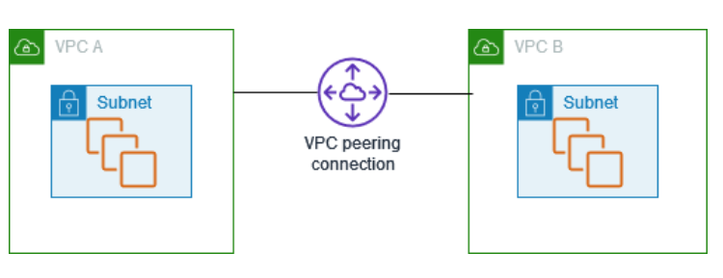

**VPC Endpoint:**

* **A VPC endpoint enables you to privately connect your VPC to supported AWS services, instances in your VPC do not require public IP address to communicate with resources in the service. Endpoints are virtual devices.**

**What is VPC peering connection?**

1. Requester

2.Acesspter.

**Can we do VPC Peering b/w VPC which are in different Regions?**

We can do this

1. same Account same region.

2. same account different region

3. Diff Account same region

4. different account different region

**VPC Flow Logs**

🡺 A flow log captures information about the IP traffic going to and from network interfaces in your VPC.

**Traffic Mirroring**

**🡺** Copy network traffic from network interfaces and send it to security and monitoring appliances for deep packet inspection.

**Transit gateways**

**🡺** Use a transit gateway, which acts as a central hub, to route traffic between your VPCs, VPN connections, and AWS Direct Connect connections.

**VPN connections**

🡺 Connect your VPCs to your on-premises networks using AWS Virtual Private Network (AWS VPN).

**Elastic IP address**

🡺It is a static public IPv4 address associated with your AWS account in a specific region. Unlike an auto-assigned public IP address, an Elastic IP address is preserved after you stop and start your instance in a virtual private cloud (VPC).

Interview Q:

1. **Name and explain some security products and features available in VPC?**

**1.** Security groups - This goes about as a firewall for the EC2 examples, controlling inbound and outbound traffic at the case level.

**2.** Network access control lists - It goes about as a firewall for the subnets, controlling inbound and outbound traffic at the subnet level.

**3.** Flow logs - These catch the inbound and outbound traffic from the system interfaces in your VPC.

---------

2.**How do you monitor Amazon VPC?**

You can use the following tools to monitor traffic or network access in your virtual private cloud (VPC).

1.**VPC Flow Logs** - You can use VPC Flow Logs to capture detailed information about the traffic going to and from network interfaces in your VPCs.

**2. Amazon VPC IP Address Manager (IPAM)** - You can use IPAM to plan, track, and monitor IP addresses for your workloads. For more information, see IP Address Manager.

3. **Traffic Mirroring**

**4.** **Reachability Analyzer**

**5.** **Network Access Analyzer**

**6.** **CloudTrail logs**

**Day: -5**

**AWS Security**

* how to implement security measures such as security groups, network ACLs (Access Control Lists), and IAM policies to ensure the confidentiality, integrity, and availability of your AWS resources.

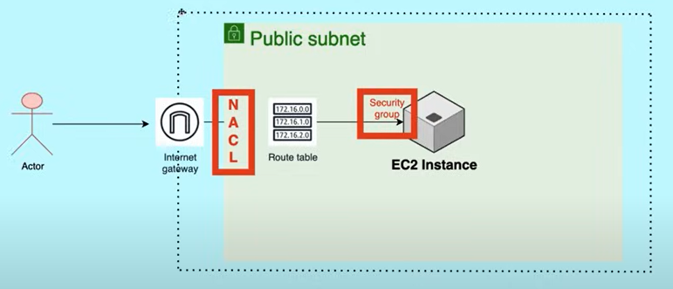

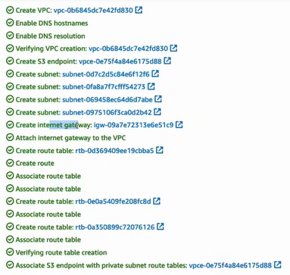

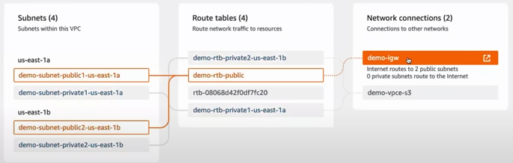

**Day-6:**

**Route 53**

🡺 **Route 53 on AWS provides DNS as a service.**

**What is DNS?**

* DNS – Domain name system

🡺 The Internet’s DNS system works much like a phone book by managing the mapping between names and numbers.

🡺DNS servers translate requests for names into IP addresses, controlling which server an end user will reach when they type a domain name into their web browser. These requests are called queries.

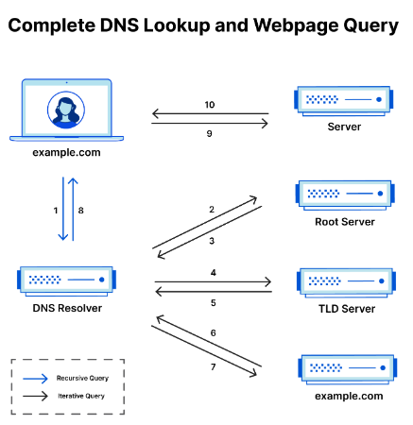

**What is Route 53?**

🡺 You can use Route 53 in the Networking and Content Delivery section in AWS Console.

🡺Route 53 is a highly available and scalable DNS web Service by Amazon.

🡺 It is a **scalable (DNS) service that provides a reliable** way to **redirect traffic to applications**. To achieve this domain names are translated to IP addresses to help computers connect better.

🡺 It is possible to connect queries to entities like Elastic Load Balancers in AWS using Amazon Route 53.

🡺**Route 53 is mainly used for 3 purposes: -**

**1.DNS Registration**: - Your website or web application needs a name; Route 53 lets you register a name for the same.

2. **Route Internet Traffic**: - Route 53 helps you connect with your website or web application when you search for your domain name on your browser.

**3.Check Health Status**: - Route 53 sends automated request over internet **to check the availability** of **your website or web application** and sends you notification if it is unavailable so that you can route the requests to a healthy resource.

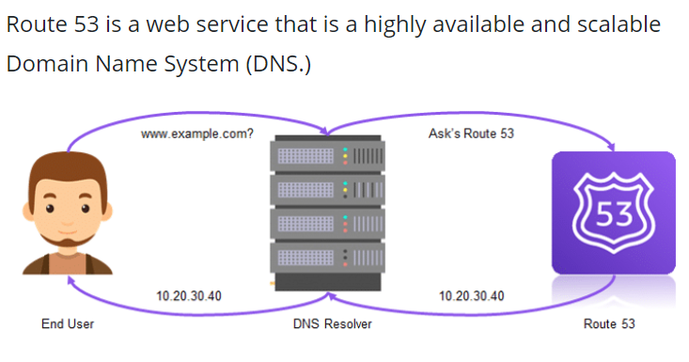

Day:7

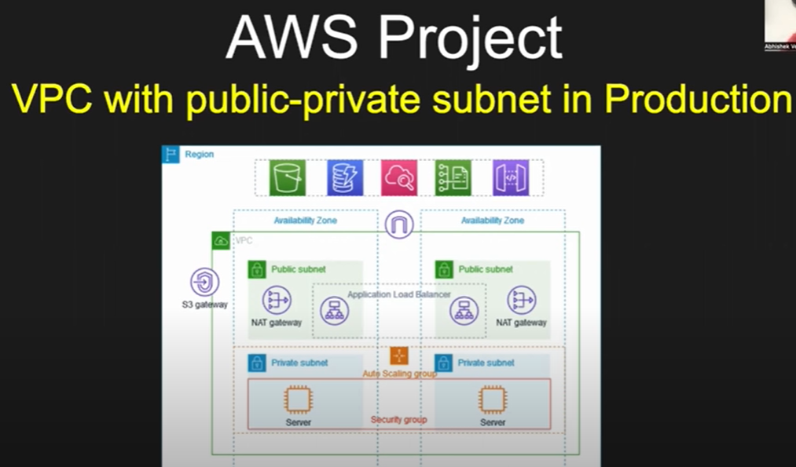

**Project:**

* **Design and configure a VPC:** Create a VPC with custom IP ranges. Set up public and private subnets. Configure route tables and associate subnets.
* **Implement network security:** Set up network access control lists (ACLs) to control inbound and outbound traffic. Configure security groups for EC2 instances to allow specific ports and protocols.
* **Provision EC2 instances:** Launch EC2 instances in both the public and private subnets. Configure security groups for the instances to allow necessary traffic. Create and assign IAM roles to the instances with appropriate permissions.
* **Networking and routing:** Set up an internet gateway to allow internet access for instances in the public subnet. Configure NAT gateway or NAT instance to enable outbound internet access for instances in the private subnet. Create appropriate route tables and associate them with the subnets.
* **SSH key pair and access control:** Generate an SSH key pair and securely store the private key. Configure the instances to allow SSH access only with the generated key pair. Implement IAM policies and roles to control access and permissions to AWS resources.
* **Test and validate the setup:** SSH into the EC2 instances using the private key and verify connectivity. Test network connectivity between instances in different subnets. Validate security group rules and network ACL settings.

**Real time Production grad AWS project: -**

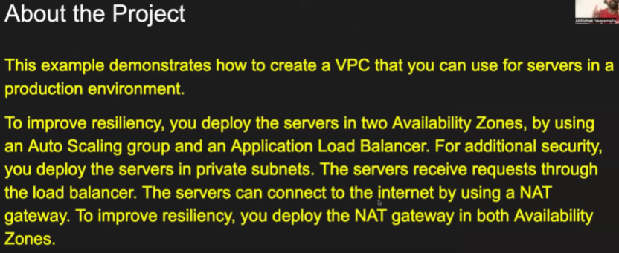

**Project_OverView:**

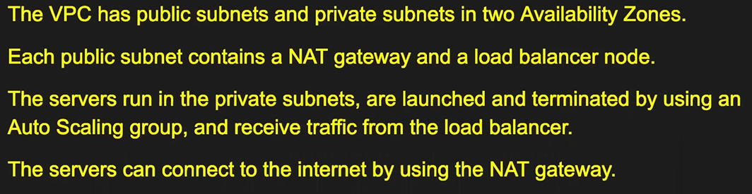

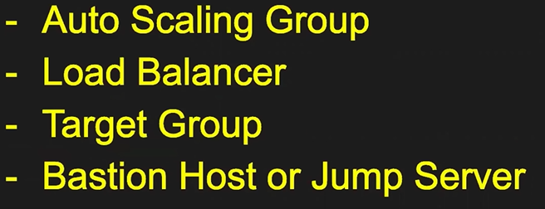

**What is Auto Scaling?**

**🡺** An auto scaling group contains a collection of EC2 instances that are treated as a logical grouping for the purposes of automatic scaling and management.

🡺AWS Auto Scaling allows **automatically adding or removing EC2 instances based on demand,** ensuring your application can handle traffic spikes without disruption.

**What is Load Balancing?**

 🡺[Load balancing](https://cloudiofy.com/load-balancer-in-aws/) is the process of **distributing incoming network traffic or computational workload across multiple resources**, such as servers, to optimize resource utilization, improve performance, and ensure high availability of services.

🡺Load balancers typically monitor the health and capacity of individual resources and direct traffic in a way that minimizes response time and maximizes throughput.

**Types**

1. **Application Load Balancer**
2. **Network Load Balancer.**
3. **Gateway Load Balancer.**
4. **Classic Load Balancer.**

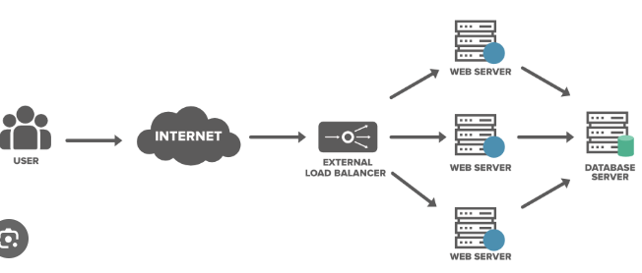

**What is Target Group**

**🡺** The target group determines how traffic is distributed to your instances.

**(OR)**

🡺 Target groups route requests to individual registered targets, such as EC2 instances, using the protocol and port number that you specify. You can register a target with multiple target groups. You can configure health checks on a per target group basis.

**What is Bastion Host or Jump Server.**

🡺 A bastion host is a server whose **purpose is to provide access to a private network from an external network, such as the Internet**.

**(OR)**

**🡺** The bastion hosts **provide secure access to instances located in the private and public subnets of your VPC.** This is the concept to access critical data instance from trusted instance only and prevents the access from internet.

Step:1

🡺 To create the VPC Open the Amazon VPC console at https://console.aws.amazon.com/vpc/.

🡺 On the dashboard, choose Create VPC.

🡺For Resources to create, choose VPC and more button.

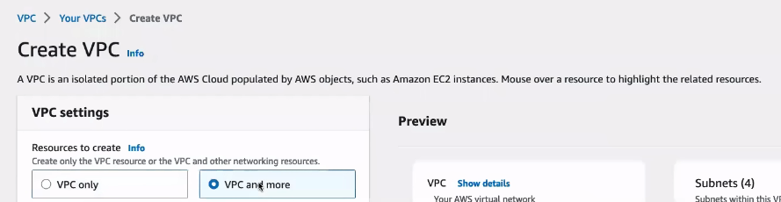

2. In preview Diagram.

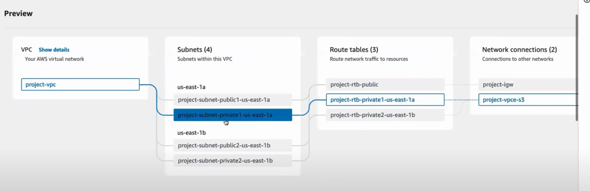

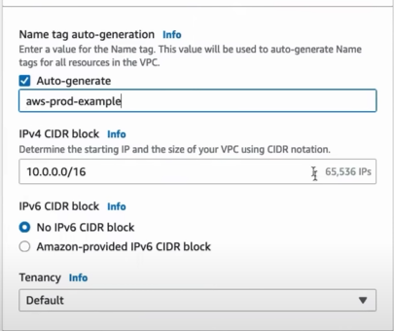

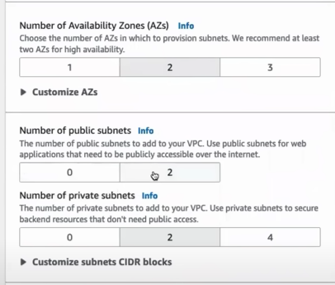

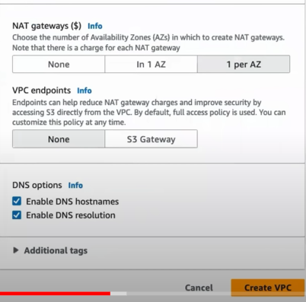

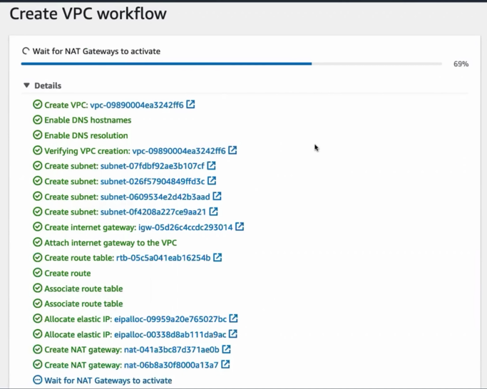

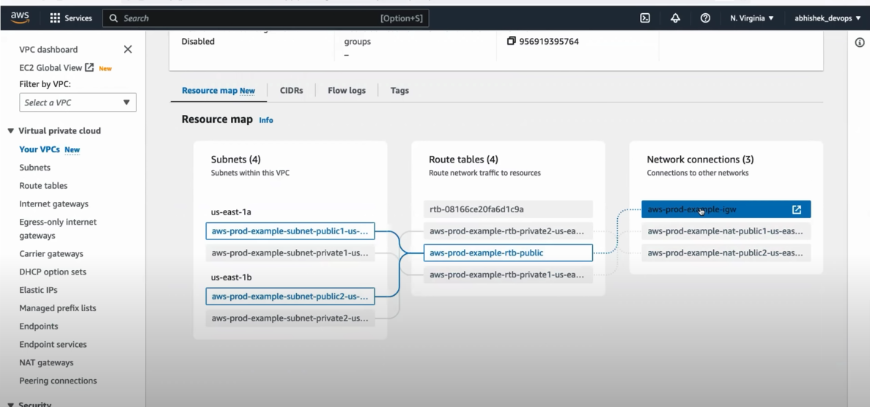

**Step:3** Creating Auto Scaling Group

**🡺 In the Ec2 instance we can go for Auto Scaling Groups**

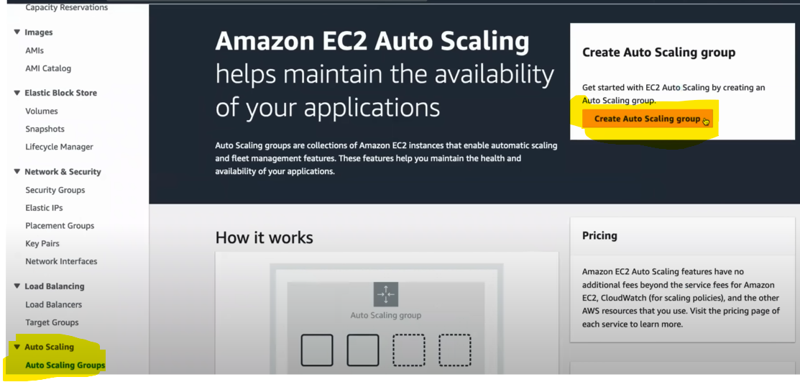

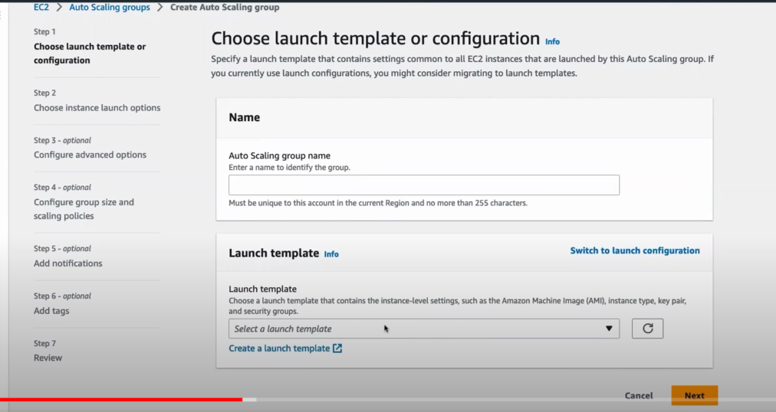

**🡺 Click on Lunch Template**

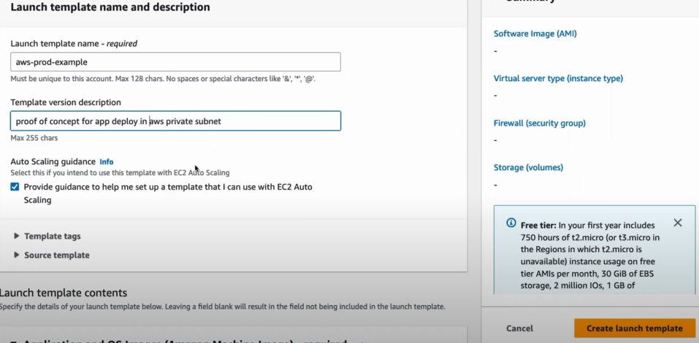

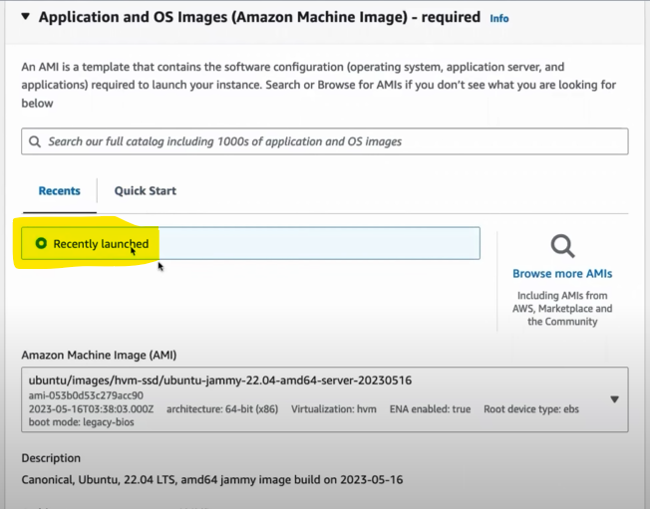

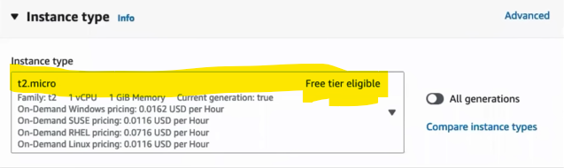

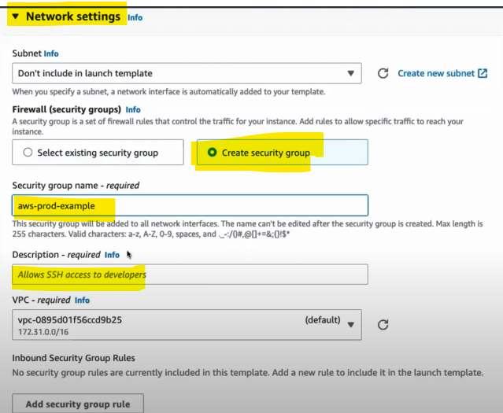

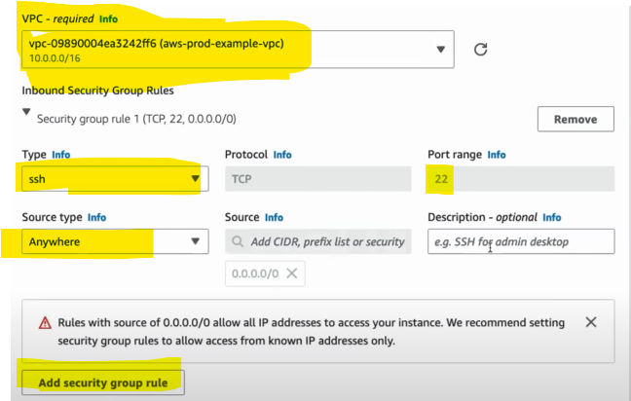

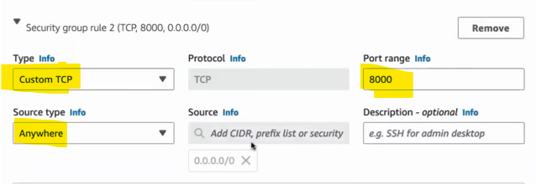

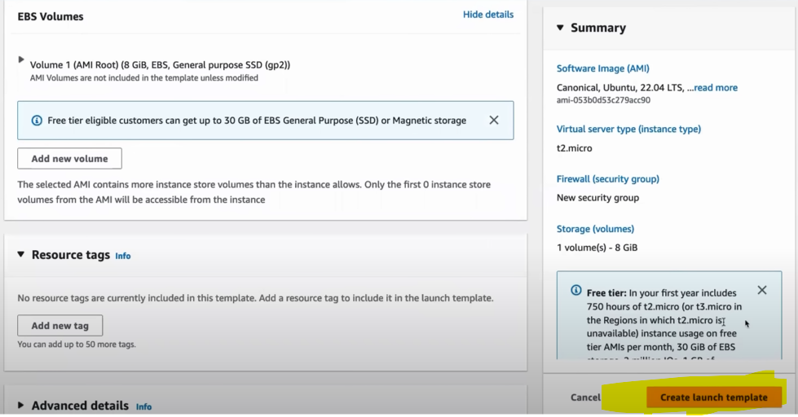

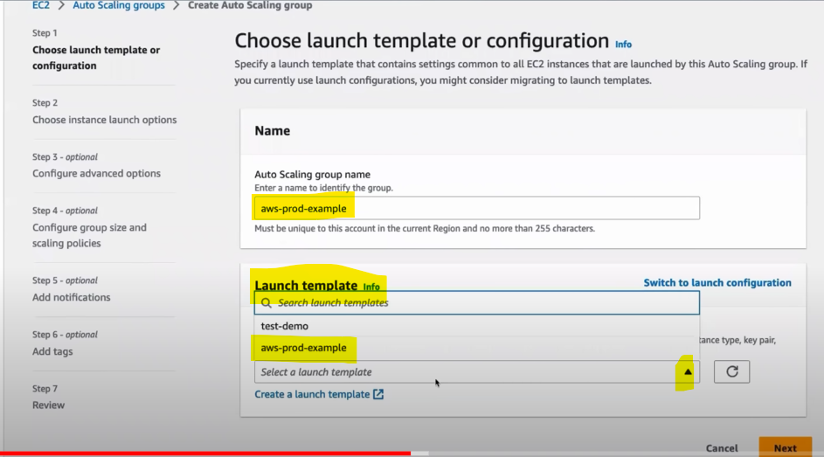

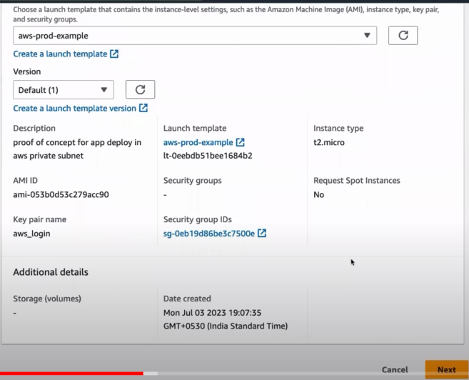

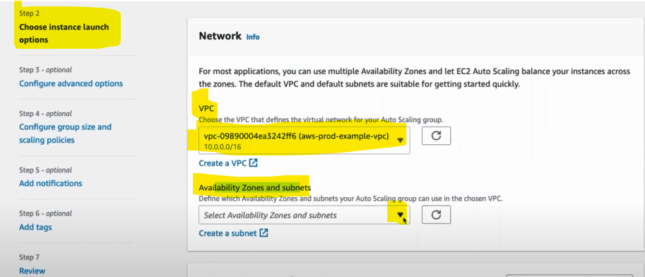

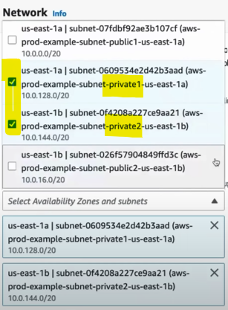

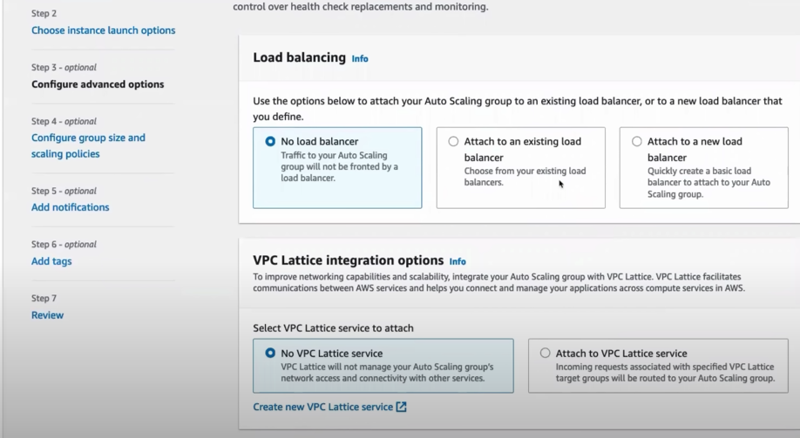

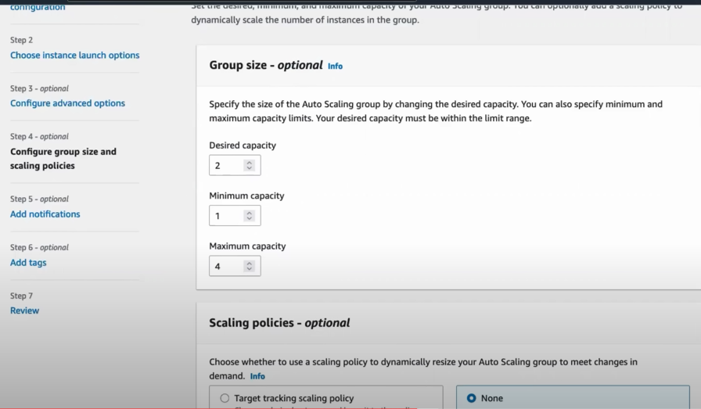

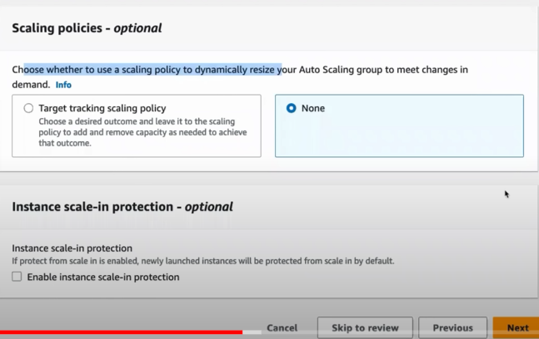

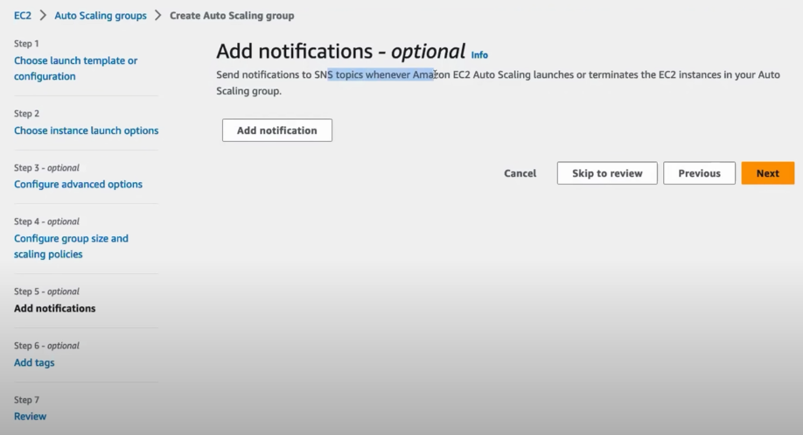

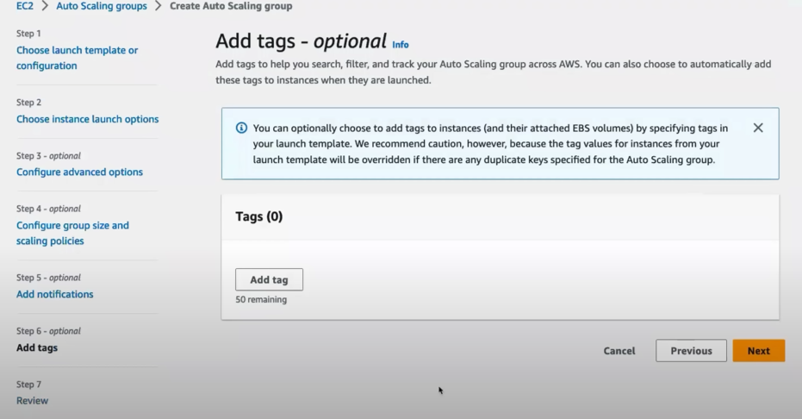

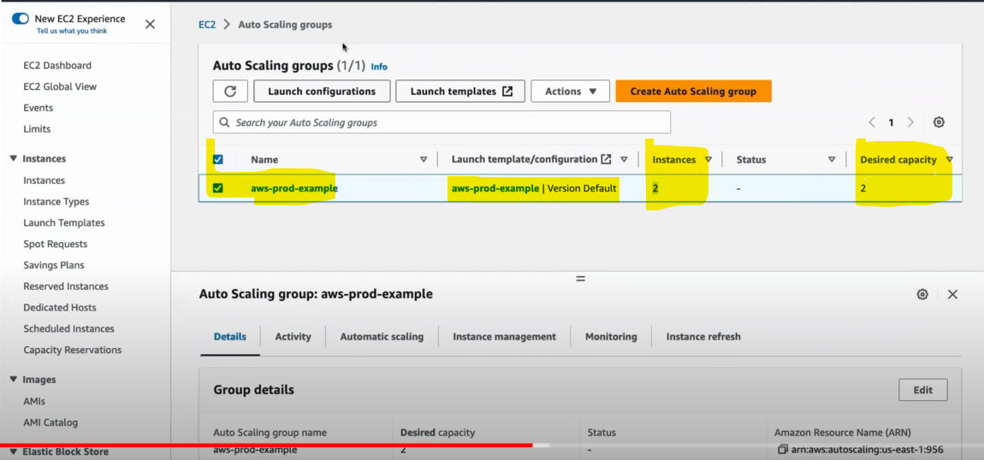

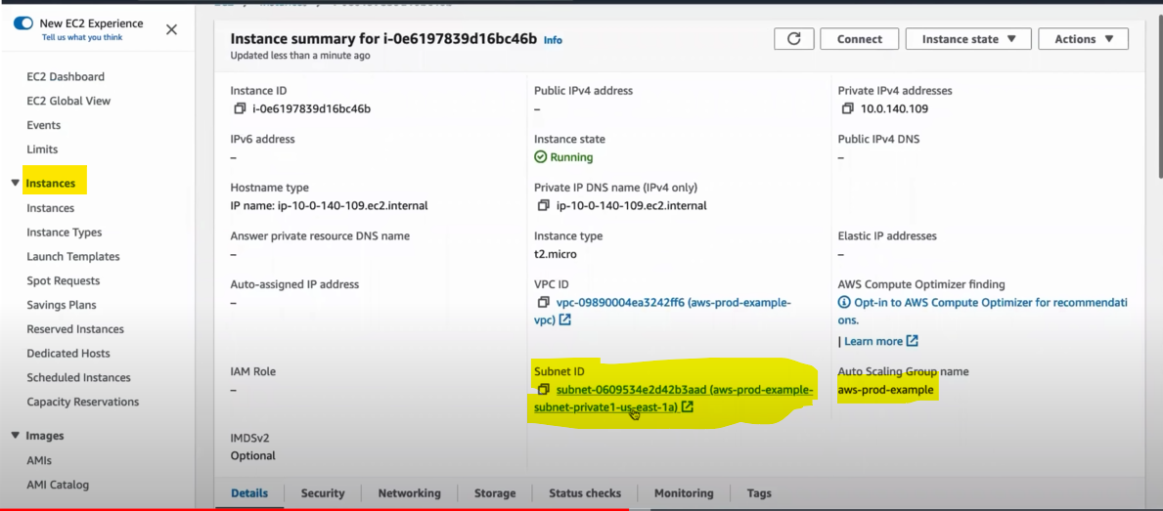

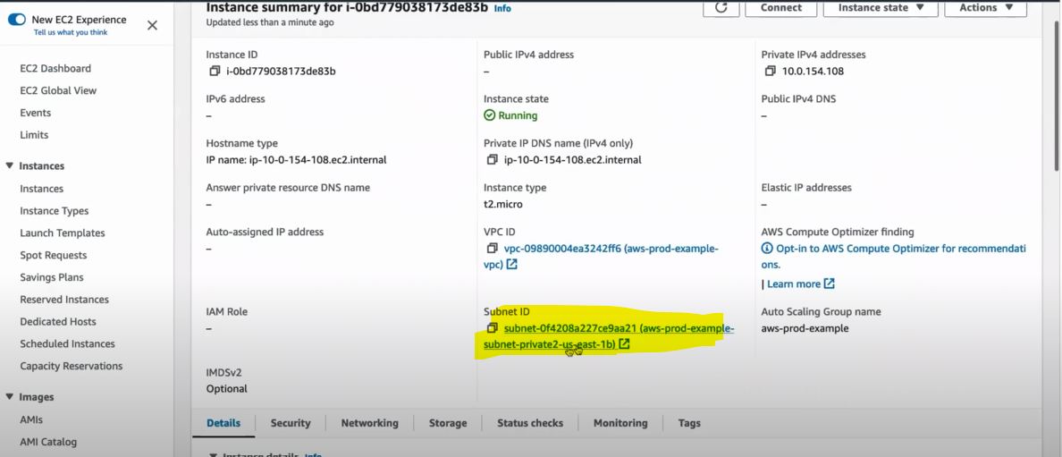

**Step:4**

🡺 Before creating Application Load balancer.

🡺 Come to instance open any one instance check the Public IPV4 address not there.

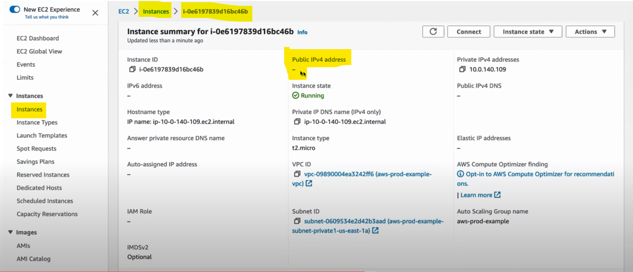

🡺 Now creating Bastion host

* Click launch instance button --> Name (Bastion_host) ----> AMI (Ubuntu- anything) ----> Instance type (t2.micro) ---->keypair -----> **Network Settings** – click edit button(VPC – required info – change what are creating (aws-prod-example-vpc)) – Auto-Assign public IP (Enable) -----> **Firewall Security group** (Create security Group – Allow SSH traffic form ) ---> Click lunch instance Button.

Hint:

🡺 **Personal Laptop to SSH, SSH to Bastion, From bastion to SSH to the private subnet. But to SSH to the private subnet again you want to key value pair which is present in laptop**

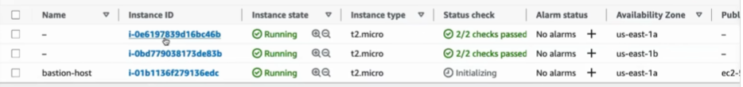

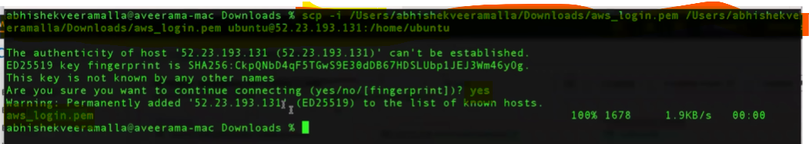

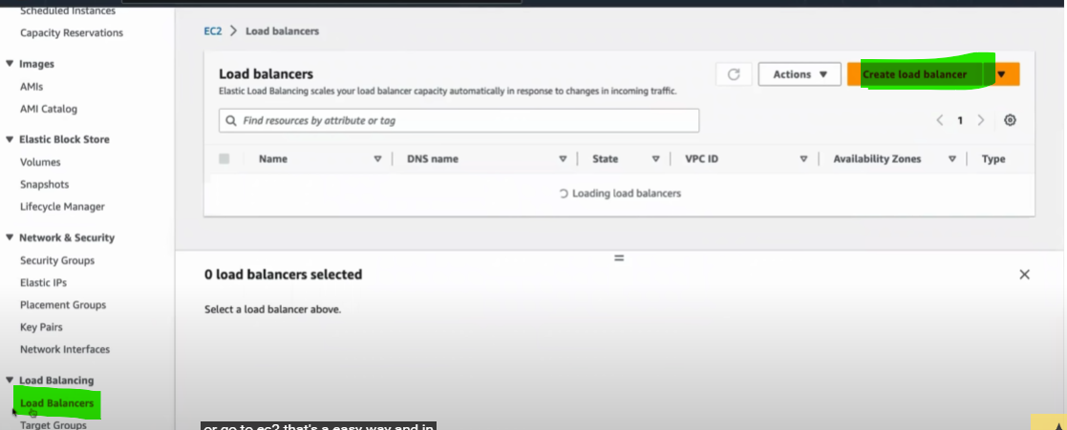

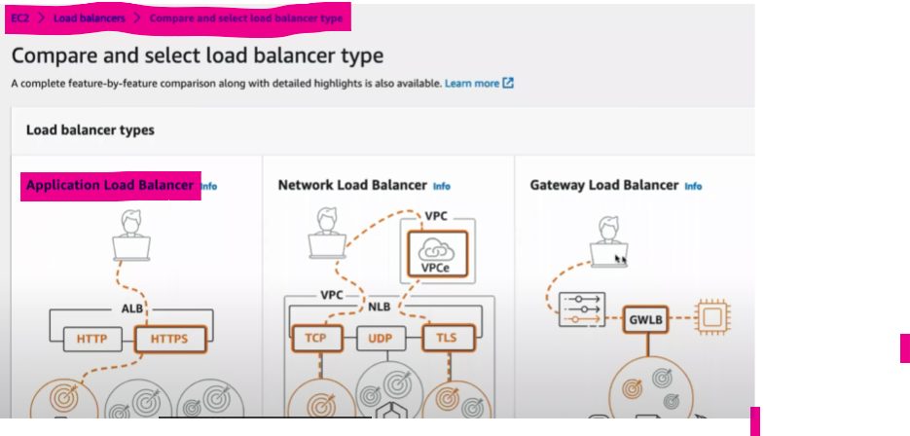

**What is Application Load balancer?**

**🡺** It does the http and https which is L7 Load balancer.

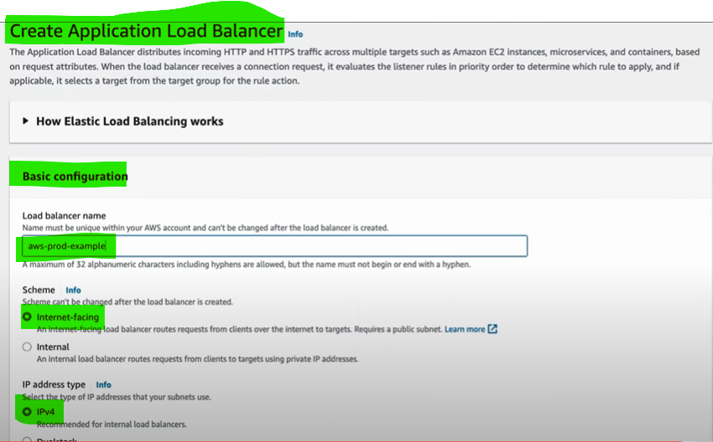

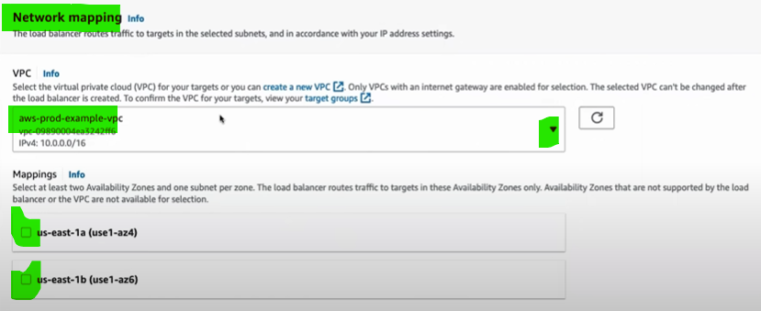

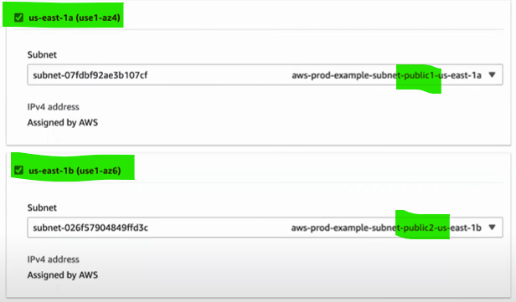

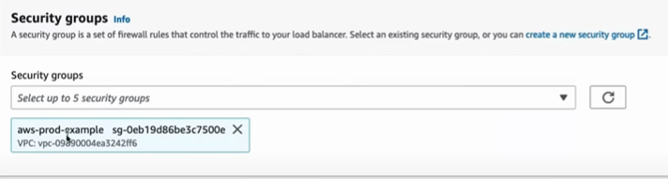

**🡺 Create a target Group**

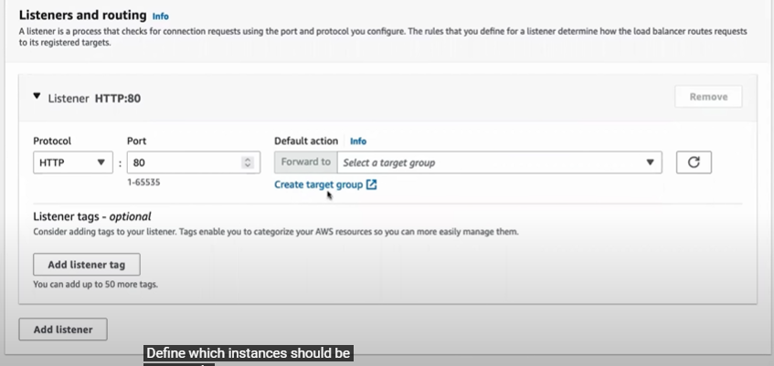

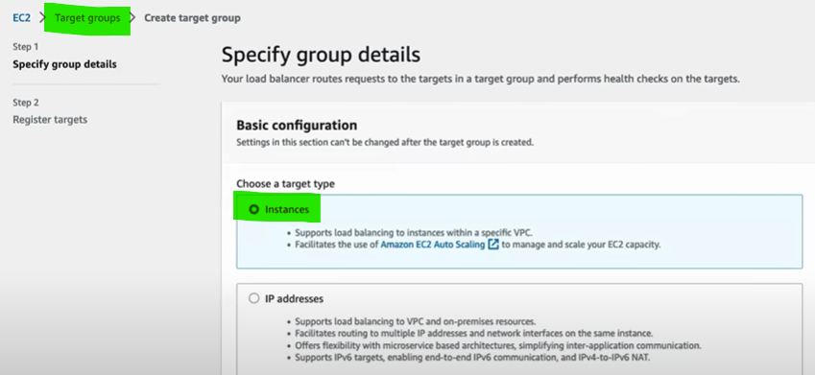

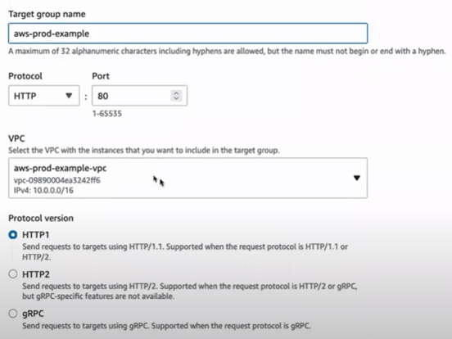

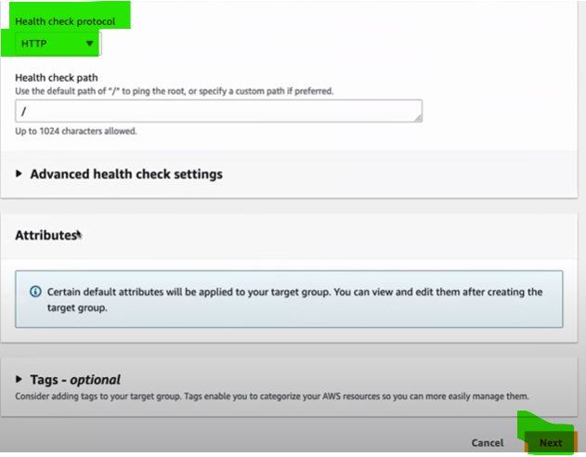

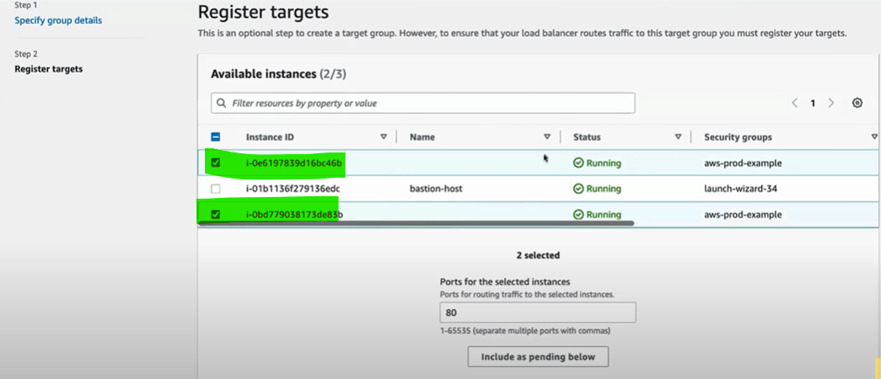

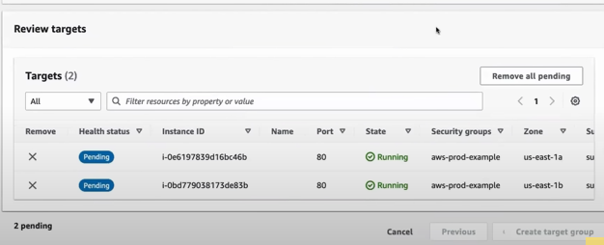

**Day-08**

**(AWS Interview Questions on EC2, IAM and VPC)**

**# Scenario Based Interview Questions on EC2, IAM and VPC**

**1Q:** You have been assigned to design a VPC architecture for a 2-tier application. The application needs to be highly available and scalable.

How would you design the VPC architecture?

A: In this scenario, I would design a VPC architecture in the following way.

🡺 I would create 2 subnets: **public and private**.

* The **public subnet** would contain the **load balancers and be accessible from the internet.**
* The **private subnet** would **host the application servers**.

I would distribute the subnets across **multiple Availability Zones** for high availability. Additionally, I would configure **auto scaling groups** for the application servers.

**2Q:** Your organization has a VPC with multiple subnets. You want to restrict outbound internet access for resources in one subnet but allow outbound internet access for resources in another subnet. How would you achieve this?

A: To restrict outbound internet access for resources in one subnet, we **can modify the route table associated with that subnet.** In the route table, **we can remove the default route (0.0.0.0/0) that points to an internet gateway.**

This would prevent resources in that subnet from accessing the internet. For the subnet where outbound internet access is required, we **can keep the default route pointing to the internet gateway**.

**3Q:** You have a VPC with a public subnet and a private subnet. Instances in the private subnet need to access the internet for software updates. How would you allow internet access for instances in the private subnet?

A: To allow internet access for instances in the private subnet, we can **use a NAT Gateway or a NAT instance**.

We would place the NAT Gateway/instance in the public subnet and configure the private subnet route table to send outbound traffic to the NAT Gateway/instance. This way, instances in the private subnet can access the internet through the NAT Gateway/instance.

**4Q:** You have launched EC2 instances in your VPC, and you want them to communicate with each other using private IP addresses. What steps would you take to enable this communication?

A: By default, instances within the same VPC can communicate with each other using private IP addresses.

🡺 To ensure this communication, we need **to make sure that the instances are launched in the same VPC** and are placed in the same **subnet or subnets that are connected** through a peering connection or a **VPC peering link**.

🡺 Additionally, we should check the security groups associated with the instances to ensure that the necessary inbound and outbound rules are configured to allow communication between them.

**Imp ***5Q:** You want to **implement strict network access** control for your VPC resources. How would you achieve this?

A: To implement granular network access control for VPC resources, we can use **Network Access Control Lists (ACLs).**

🡺 NACLs are stateless and operate at the subnet level. We can define **inbound and outbound rules in the NACLs to allow or deny traffic based on source and destination IP addresses, ports, and protocols**.

🡺 By carefully configuring NACL rules, we can enforce fine-grained access control for traffic entering and leaving the subnets.

**6Q:** Your organization requires an isolated environment within the VPC for running sensitive workloads. How would you set up this isolated environment?

A: To set up an isolated environment within the VPC, **we can create a subnet** with no internet gateway attached.

🡺This subnet, known as an "isolated subnet," **will not have direct internet connectivity.** We can place the sensitive workloads in this subnet, ensuring that they are protected from inbound and outbound internet traffic.

🡺 However, if these workloads require outbound internet access, we can set up a NAT Gateway or NAT instance in a different subnet and configure the isolated subnet's route table to send outbound traffic through the NAT Gateway/instance.

**7Q:** Your application needs to access AWS services, such as S3 securely within your VPC. How would you achieve this?

A: To securely access AWS services within the VPC, we can use VPC endpoints. **VPC endpoints allow instances** in the VPC to communicate with AWS services privately, **without requiring internet gateways or NAT gateways.**

🡺 We can create VPC endpoints for specific AWS services, such as S3 and DynamoDB, and associate them with the VPC.

🡺 This enables secure and efficient communication between the instances in the VPC and the AWS services.

**8Q:** What is the difference between NACL and Subnet? Security group? Explain with a use case?

A: For example, I want to design a security architecture, I would use a combination of NACLs and security groups. **At the subnet level, I would configure NACLs to enforce inbound and outbound traffic restrictions** based on source and destination IP addresses, ports, and protocols. **NACLs are stateless** and can provide an additional layer of defense by filtering traffic at the subnet boundary.

🡺 At the **instance level, I would leverage security groups to control** inbound and outbound traffic. **Security groups are stateful** and operate at the instance level. By carefully defining security group rules, I can allow or deny specific traffic to and from the instances based on the application's security requirements.

🡺 By combining NACLs and security groups, I can achieve granular security controls at both the network and instance level, providing defense-in-depth for the sensitive application.

**9Q**: What is the difference between IAM users, groups, roles and policies?

A: **IAM User:** An IAM user is an **identity** within AWS that represents an individual or application needing access to AWS resources. IAM users have permanent long-term credentials, such as a username and password, or access keys (Access Key ID and Secret Access Key). IAM users can be assigned directly to IAM policies or added to IAM groups for easier management of permissions.

**IAM Role:** An IAM role is similar to an IAM user but is not associated with a specific individual. Instead, it is assumed by entities such as IAM users, applications, or services to obtain temporary security credentials. IAM roles are useful when you want to grant permissions to entities that are external to your AWS account or when you want to delegate access to AWS resources across accounts. IAM roles have policies attached to them that define the permissions granted when the role is assumed.

**IAM Group:** An IAM group is a **collection of IAM users**. By organizing IAM users into groups, you can manage permissions collectively. **IAM groups make it easier to assign permissions to multiple users simultaneously**. Users within an IAM group inherit the permissions assigned to that group. For example, you can create a "Developers" group and assign appropriate policies to grant permissions required for developers across your organization.

**IAM Policy:** **An IAM policy is a document that defines permissions and access controls in AWS**. IAM policies can be attached to IAM users, IAM roles, and IAM groups to define what actions can be performed on which AWS resources. IAM policies use JSON (JavaScript Object Notation) syntax to specify the permissions and can be created and managed independently of the users, roles, or groups. IAM policies consist of statements that include the actions allowed or denied, the resources on which the actions can be performed, and any additional conditions.

**10Q:** You have a private subnet in your VPC that contains a number of instances that **should not have direct internet access**. However, you still need to be able to securely access these instances for administrative purposes. How would **you set up a bastion host to facilitate this access**?

A: To securely access the instances in the private subnet, you can set up a bastion host (also known as a jump host **or jump box**). The **bastion host** acts as a secure entry point to your private subnet. Here's how you can set up a bastion host:

🡺 Create a new EC2 instance in a public subnet, which will serve as the bastion host. Ensure that this instance has a public IP address or is associated with an Elastic IP address for persistent access.

🡺 Configure the security group for the bastion host to allow inbound SSH (or RDP for Windows) traffic from your IP address or a restricted range of trusted IP addresses. This limits access to the bastion host to authorized administrators only.

🡺 Place the instances in the private subnet and configure their security groups to allow inbound SSH (or RDP) traffic from the bastion host security group.

🡺 SSH (or RDP) into the bastion host using your private key or password. From the bastion host, you can then SSH (or RDP) into the instances in the private subnet using their private IP addresses.

**Day-9 – AWS S3**

**S3 (Simple Storage Service) – Parts-1**

* 1. What is Amazon S3?
  2. Public and private access in S3.
  3. Pre-signed URL in S3.
  4. Bucket Policy.
  5. Versioning in S3.
  6. Access control lists (ACLs) in S3.
  7. Storage classes in s3.
  8. Lifecycle management in S3.
  9. Static website hosting in S3.
  10. Encryption and MFA delete in S3.
  11. Cross-Origin resource sharing (CORS).
  12. Tags in S3.

**What is Amazon S3?**

🡺Simple Storage Service is a **scalable, Highly Available , Cost effective and secure cloud** storage service provided by Amazon Web Services (AWS).

🡺It allows you to store and retrieve any amount of data from anywhere on the web.

**(OR)**

🡺 Amazon **Simple Storage Service** (Amazon S3) is a scalable **object storage service** designed to store and retrieve any amount of data from anywhere on the web. It's commonly used to store files, backups, images, videos, and more.

🡺It looks similar to your Google drive/ one drive and also allow unlimited amount of data (Highly scalable – Up to 5TD per file).

**What are S3 buckets? / What can you store in these S3?**

**🡺**S3 buckets are containers for storing objects (files, images, videos, and more.) in Amazon S3. Each bucket has a unique name **globally across all of AWS**.

🡺You can think of an S3 bucket as a **top-level folder that holds your data.**

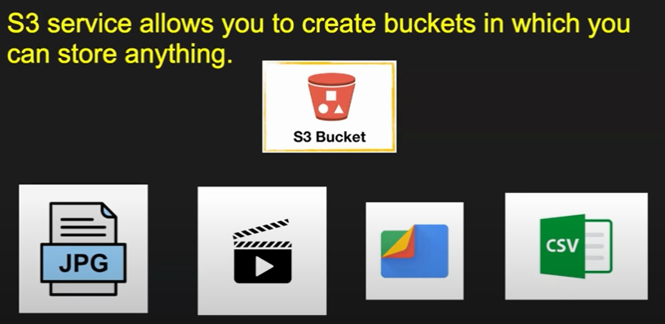

**Why use S3 buckets?**

🡺S3 buckets provide a reliable and highly scalable storage solution for various use cases.

🡺 They are commonly used for backup and restore, data archiving, content storage for websites, and as a data source for big data analytics.

Key **benefits** of S3 buckets (S3 buckets offer several **advantages**,) including:

1. **Durability and availability:** S3 provides high durability and availability for your data.
2. **Scalability**: You can store and retrieve any amount of data without worrying about capacity constraints.
3. **Security:** S3 offers multiple security features such as encryption, access control, and audit logging.
4. **Performance:** S3 is designed to deliver high performance for data retrieval and storage operations.
5. **Cost-effective:** S3 offers cost-effective storage options and pricing models based on your usage patterns.

**Pre-signed URL in S3.**

🡺A pre-signed URL uses **security credentials to grant time-limited permission** to download objects. The URL can be entered in a browser or used by a program to download the object. A pre-signed URL is signed with your credentials and can be used by any user.

🡺 A pre-signed URL uses three parameters to limit the access to the user.

* **Bucket:** The bucket that the object is in (or will be in)
* **Key**: The name of the object
* **Expires:** The amount of time that the URL is valid

**Public and private access in S3.**

1. An S3 bucket is considered as Private if that does not have any public access provided to any of its ACL or bucket policy.
2. S3 is bucket if it has provided access for external people to read/write/upload[**content**](https://www.liainfraservices.com/content-writing-service) files.
3. A public bucket is one that everyone can access from the internet. A private one is not.
4. Private buckets are accessible only to authorized users, while public buckets can be accessed by anyone with the bucket's URL.
5. There are three levels’ to counted public.
   * Service level – Default public.
   * Bucket level – Public.
   * Object level – Private.

## Creating and Configuring S3 Buckets

**1.Creating an S3 bucket**

🡺To create an S3 bucket, you can use the

1. AWS Management Console.
2. AWS CLI (Command Line Interface), or AWS SDKs (Software Development Kits).

* You need to specify a globally unique bucket name and select the region where you want to create the bucket.

2.Choosing a bucket name and region

1. The bucket name must be **unique across all existing bucket** names in Amazon S3.
2. It should follow DNS naming conventions, be 3-63 characters long, and contain only lowercase letters, numbers, periods, and hyphens.
3. The region selection affects data latency and compliance with specific regulations.

3.Bucket properties and configurations

**🡺Versioning**: Versioning allows you to keep multiple versions of an object in the bucket. It helps protect against accidental deletions or overwrites.

4. Bucket-level permissions and policies

🡺Bucket-level permissions and policies define who can access and perform actions on the bucket. You can grant **permissions using IAM** (Identity and Access Management) policies, which **allow fine-grained control over user access to the bucket and its objects.**

## Uploading and Managing Objects in S3 Buckets

**Uploading objects to S3 buckets**

**🡺**You can upload objects to an S3 bucket using various methods, including the AWS Management Console, AWS CLI, SDKs, and direct HTTP uploads. Each object is assigned a unique key (name) within the bucket to retrieve it later.

Object metadata and properties

🡺Object metadata contains additional information about each object in an S3 bucket. It includes attributes like content type, cache control, encryption settings, and custom metadata. These properties help in managing and organizing objects within the bucket.

File formats and object encryption

🡺S3 supports various file formats, including text files, images, videos, and more. You can encrypt objects stored in S3 using server-side encryption (SSE). SSE options include SSE-S3 (Amazon-managed keys), SSE-KMS (AWS Key Management Service), and SSE-C (customer-provided keys).

Lifecycle management

🡺Lifecycle management allows you to define rules for transitioning objects between different storage classes or deleting them automatically based on predefined criteria. For example, you can move infrequently accessed data to a lower-cost storage class after a specified time or delete objects after a certain retention period.

Multipart uploads

🡺Multipart uploads provide a mechanism for uploading large objects in parts, which improves performance and resiliency. You can upload each part in parallel and then combine them to create the complete object. Multipart uploads also enable resumable uploads in case of failures.

Managing large datasets with S3 Batch Operations

🡺S3 Batch Operations is a feature that allows you to perform bulk operations on large numbers of objects in an S3 bucket. It provides an efficient way to automate tasks such as copying objects, tagging, and restoring archived data.

## Advanced S3 Bucket Features

## S3 Storage Classes

## 🡺S3 offers multiple storage classes, each designed for different use cases and performance requirements:

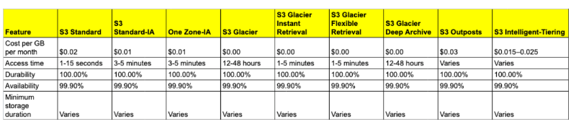

**S3 Replication**

🡺S3 replication enables automatic and asynchronous replication of objects between S3 buckets in different regions or within the same region. Cross-Region Replication (CRR) provides disaster recovery and compliance benefits, while Same-Region Replication (SRR) can be used for data resilience and low-latency access.

S3 Event Notifications and Triggers

🡺S3 event notifications allow you to configure actions when specific events occur in an S3 bucket. For example, you can trigger AWS Lambda functions, send messages to Amazon Simple Queue Service (SQS), or invoke other services using Amazon SNS when an object is created or deleted.

S3 Batch Operations

🡺S3 Batch Operations allow you to perform large-scale batch operations on objects, such as copying, tagging, or deleting, across multiple buckets. It simplifies managing large datasets and automates tasks that would otherwise be time-consuming.

## Security and Compliance in S3 Buckets

S3 bucket security considerations

Ensure that S3 bucket policies, access control, and encryption settings are appropriately configured. Regularly monitor and audit access logs for unauthorized activities.

Data encryption at rest and in transit

Encrypt data at rest using server-side encryption options provided by S3. Additionally, enable encryption in transit by using SSL/TLS for data transfers.

Access logging and monitoring

Enable access logging to capture detailed records of requests made to your S3 bucket. Monitor access logs and configure alerts to detect any suspicious activities or unauthorized access attempts.

## S3 Bucket Management and Administration

S3 bucket policies

Create and manage bucket policies to control access to your S3 buckets. Bucket policies are written in JSON and define permissions for various actions and resources.

S3 access control and IAM roles

Use IAM roles and policies to manage access to S3 buckets. IAM roles provide temporary credentials and fine-grained access control to AWS resources.

S3 APIs and SDKs

Interact with S3 programmatically using AWS SDKs or APIs. These provide libraries and methods for performing various operations on S3 buckets and objects.

Monitoring and logging with CloudWatch

Utilize Amazon CloudWatch to monitor S3 metrics, set up alarms for specific events, and collect and analyze logs for troubleshooting and performance optimization.

S3 management tools

AWS provides multiple management tools, such as the AWS Management Console, AWS CLI, and third-party tools, to manage S3 buckets efficiently and perform operations like uploads, downloads, and bucket configurations.

## Troubleshooting and Error Handling

Common S3 error messages and their resolutions

Understand common S3 error messages like access denied, bucket not found, and exceeded bucket quota. Troubleshoot and resolve these errors by checking permissions, bucket configurations, and network connectivity.

Debugging S3 bucket access issues

Investigate and resolve issues related to access permissions, IAM roles, and bucket policies. Use tools like AWS CloudTrail and S3 access logs to identify and troubleshoot access problems.

Data consistency and durability considerations

Ensure data consistency and durability by understanding S3's data replication and storage mechanisms. Verify that data is correctly uploaded, retrieve objects using proper methods, and address any data integrity issues.

Recovering deleted objects

If an object is accidentally deleted, you can often recover it using versioning or S3 event notifications. Additionally, consider enabling Cross-Region Replication (CRR) for disaster recovery scenarios.

**S3 (Simple Storage Service) – Parts-1**

* 1. What is Amazon S3?
  2. Public and private access in S3.
  3. Pre-signed URL in S3.
  4. Bucket Policy.
  5. Versioning in S3.
  6. Access control lists (ACLs) in S3.
  7. Storage classes in s3.
  8. Lifecycle management in S3.
  9. Static website hosting in S3.
  10. Encryption and MFA delete in S3.
  11. Cross-Origin resource sharing (CORS).
  12. Tags in S3.

**What is Amazon S3?**

1. Amazon **Simple Storage Service** (Amazon S3) is a scalable **object storage service** designed to store and retrieve any amount of data from anywhere on the web. It's commonly used to store files, backups, images, videos, and more.
2. It looks similar to your Google drive/ one drive and also allow unlimited amount of data (Highly scalable – Up to 5TD per file).

**Pre-signed URL in S3.**

1. A pre-signed URL uses **security credentials to grant time-limited permission** to download objects. The URL can be entered in a browser or used by a program to download the object. A pre-signed URL is signed with your credentials and can be used by any user.
2. A pre-signed URL uses three parameters to limit the access to the user.

* **Bucket:** The bucket that the object is in (or will be in)
* **Key**: The name of the object
* **Expires:** The amount of time that the URL is valid

**Public and private access in S3.**

🡺An S3 bucket is considered as Private if that does not have any public access provided to any of its ACL or bucket policy.

🡺S3 is bucket if it has provided access for external people to read/write/upload[**content**](https://www.liainfraservices.com/content-writing-service) files.

🡺A public bucket is one that everyone can access from the internet. A private one is not.

🡺 Private buckets are accessible only to authorized users, while public buckets can be accessed by anyone with the bucket's URL.

🡺There are three levels’ to counted public.

* Service level – Default public.
* Bucket level – Public.
* Object level – Private.

### [How can you control access to objects in S3?](https://github.com/iam-veeramalla/aws-devops-zero-to-hero/blob/main/interview-questions/s3.md#4-how-can-you-control-access-to-objects-in-s3)

### 🡺Access to S3 objects can be controlled using bucket policies, access control lists (ACLs), and IAM (Identity and Access Management) policies. You can define who can read, write, and delete objects.

**What is the difference between S3 Standard, S3 Intelligent-Tiering, and S3 One Zone-IA storage classes**?

* **S3 Standard:** Offers high durability, availability, and performance.
* **S3 Intelligent-Tiering:** Automatically moves objects between two access tiers based on changing access patterns.
* **S3 One Zone-IA**: Stores objects in a single availability zone with lower storage costs, but without the multi-AZ resilience of S3 Standard.

**What Is an S3 Bucket Policy?**

**🡺An S3 bucket policy is an object that allows you to manage access to specific Amazon S3 storage resources. You can specify permissions for each resource to allow or deny actions requested by a principal (a user or role).** When you create a new Amazon S3 bucket, you should set a policy granting the relevant permissions to the data forwarder’s principal roles

**S3 Versioning**

🡺S3 Versioning helps to keep multiple variants of an object in the same bucket and can be used to preserve, retrieve, and restore every version of every object stored in the S3 bucket.

🡺S3 Object Versioning can be used to protect from **unintended overwrites and accidental deletions.**

**🡺** After versioning is enabled for a bucket, if Amazon S3 receives multiple write requests for the same object simultaneously, it stores all those objects having different version id.

An s3 bucket can be in three states:

1. Un-versioned state (by default)
2. Version-enabled state
3. Version-suspended state

**(OR)**

🡺 **S3 versioning is a feature that allows you to preserve, retrieve, and restore every version of every object in a bucket. It helps protect against accidental deletion and overwrite.**

**S3 – Storage Classes**

**🡺**Amazon S3 offers a range of storage classes that you can choose from based on the data access, Resiliency, and cost requirements of your workloads.

1. **Frequently Accesses Data:**

**🡺S3 Standard.**

**🡺 S3 Reduced Redundancy.**

**🡺S3 Intelligent-Tiering.**

1. **In – Frequently Accesses Data:**

**🡺S3 Standard -Infrequent Access (S3 Standard-IA).**

**🡺S3 One Zone – Infrequent Access (S3).**

1. **Archival Data:**

**🡺S3 Glacier Instant Retrieval.**

**🡺S3 Glacier Flexible Retrieval (Formerly S3 Glacier).**

**🡺S3 Glacier Deep Archive.**

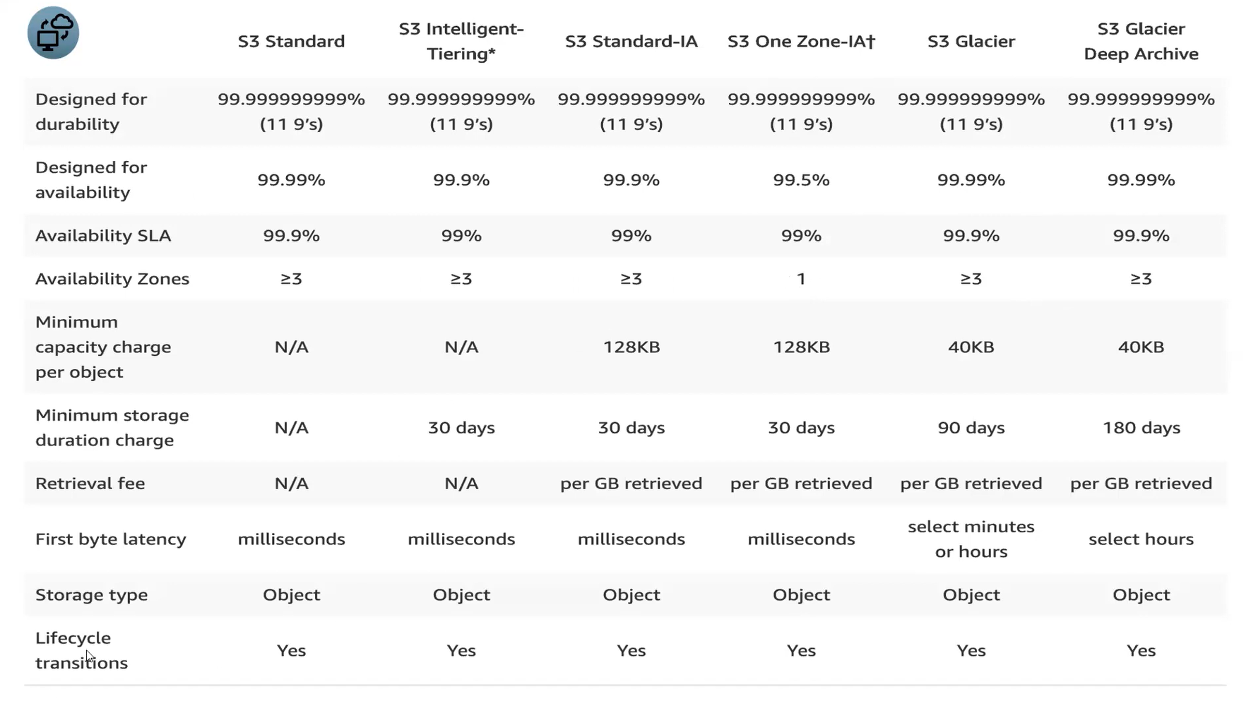

**Life Cycle management In S3**

🡺An Amazon S3 Lifecycle rule configures predefined actions to perform on objects during their lifetime. You can create a lifecycle rule to optimize your objects storage costs throughout their lifetime.

🡺You can define the scope of the lifecycle rule to all objects in your bucket to objects with a shared prefix, certain object tags, or a certain object size.

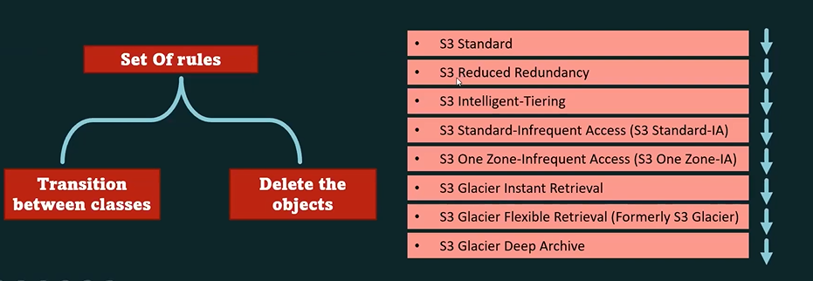

# **Access control list (ACL) overview**

🡺**Amazon S3 access control lists (ACLs) enable you to manage access to buckets and objects. Each bucket and object has an ACL attached to it as a sub resource. It defines which AWS accounts or groups are granted access and the type of access.** When a request is received against a resource, Amazon S3 checks the corresponding ACL to verify that the requester has the necessary access permissions.

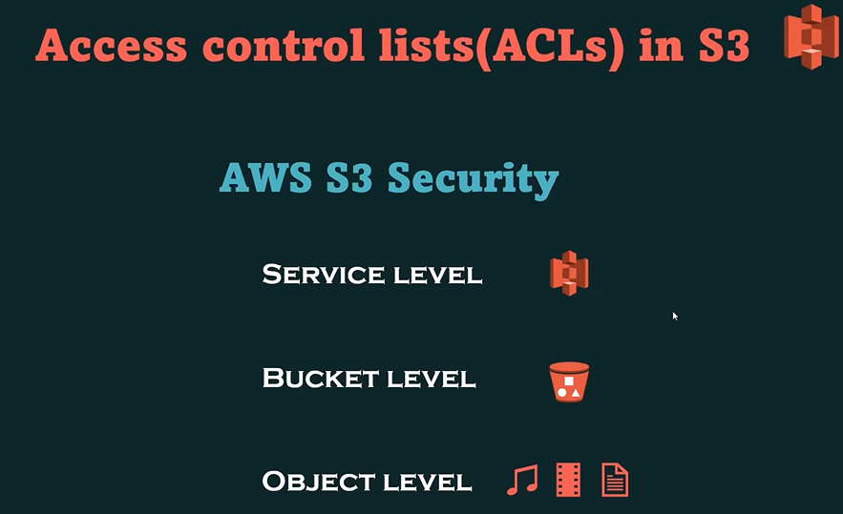

**Static website hosting in S3**.

🡺You can use Amazon S3 to host a static website. On a static website, individual webpages include static content.

🡺Using this option, you can get better management capabilities.

**Encryption:**

1. Encryption is a way of scrambling data so that **only authorized parties can understand the information.**
2. In technical terms, it is the process of converting human-readable plaintext to ciphertext.
3. In simpler terms, encryption takes readable data and alters it so that it appears random.
4. Encryption requires the use of a cryptographic key.

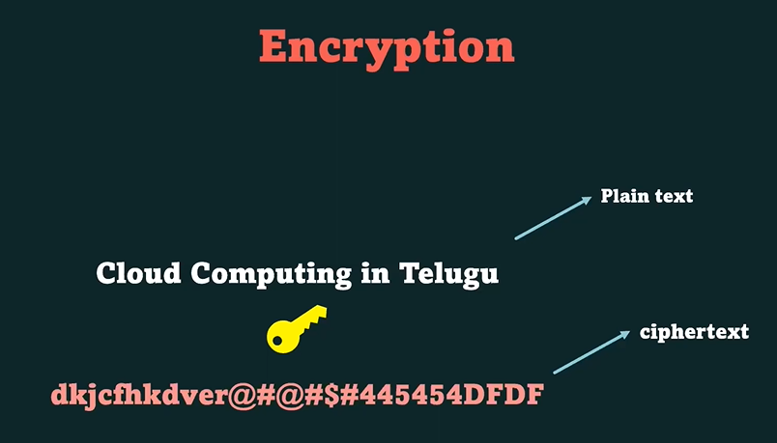

# **cross-origin resource sharing (CORS)**

🡺Cross-origin resource sharing (CORS) defines a way for client web applications that are loaded in one domain to interact with resources in a different domain. With CORS support, you can build rich client-side web applications with Amazon S3 and selectively allow cross-origin access to your Amazon S3 resources.

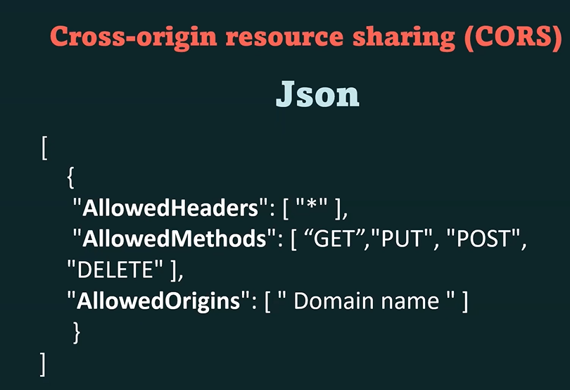

**Day-10**

**AWS CLI**

**1. What is the AWS Command Line Interface (CLI)?**

**🡺**The AWS Command Line Interface (CLI) is a unified tool that allows you to interact with various AWS services using command-line commands.

**2. Why would you use the AWS CLI?**

🡺The AWS CLI provides a convenient way to automate tasks, manage AWS resources, and interact with services directly from the command line, making it useful for scripting and administration.

**Automate Infrastructure on AWS tools:**

* AWS CLI
* Terraform
* Cloud formation
* CDK

Day -11

**AWS CloudFormation:**

* Introduces Infrastructure as Code (IaC) using AWS CloudFormation. You'll learn how to create CloudFormation templates to automate the provisioning of resources, manage stacks, and ensure consistent infrastructure across deployments.
* **Project:** You'll work on creating a CloudFormation template that provisions a fully configured application stack, including EC2 instances, networking components, and security groups.